Design 1: Narrators Opening Speech

[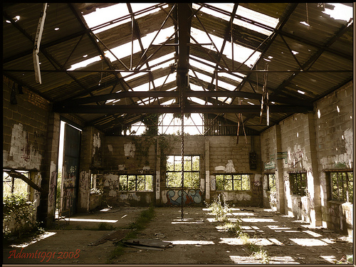](https://www.google.co.uk/url?sa=i&rct=j&q=&esrc=s&source=images&cd=&cad=rja&uact=8&ved=0ahUKEwiLzvbA2aHTAhWEOhQKHWBDCWkQjRwIBw&url=https://uk.pinterest.com/explore/abandoned-warehouse/&psig=AFQjCNHfmjTu-QwQBPl_A-pWGxCSbeKw4Q&ust=1492181704946293)

https://s-media-cache-ak0.pinimg.com/originals/5f/7e/4c/5f7e4cd6c50c1eedeebab7bc0847c6f8.jpg

**The Colour Scheme**

The colour scheme seen through many pictures of abandoned warehouses are very dark and warn. The colours seen in the pictures above are beige, brown and green; this colour scheme can be seen in films or games which are based in an apocalyptic world (I am Legend & The Last of Us). This idea links into Brodie’s idea regarding the emergency broadcast which will play at the opening of the show.

**Sunshine Beams**

The abandoned warehouse has been left to naturally self-demolish, causing openings seen in the picture above on the ceiling and in the walls. The sunlight beams shine through these gaps causing shaped shining’s on the floor. This inspires me to create similar beams shining through the scaffolding, giving the effect that the dream world has not yet been fully constructed, and gaps remain in the world.

[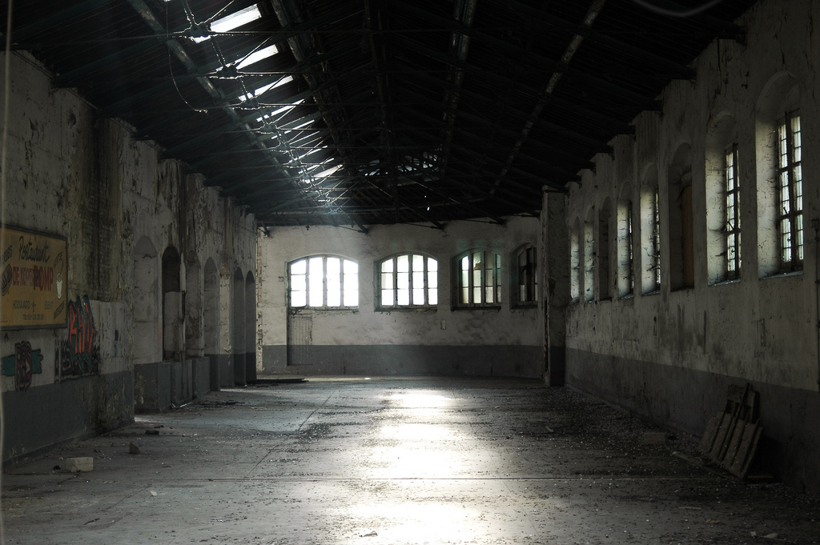](https://www.google.co.uk/url?sa=i&rct=j&q=&esrc=s&source=images&cd=&cad=rja&uact=8&ved=0ahUKEwjkhZfF3aHTAhWL1xQKHbbLBy4QjRwIBw&url=https://www.flickr.com/photos/dirkmaas/2186300964&psig=AFQjCNHfmjTu-QwQBPl_A-pWGxCSbeKw4Q&ust=1492181704946293)

https://c1.staticflickr.com/3/2272/2186300964_cabf620155_b.jpg

**Sunshine Beams (02)**

As mentioned previously, sunlight beams can be seen through the gaps of the derelict building. In person, we often see specs on dust which shimmer as they pass through the beams of light, giving me the inspiration to create the same effect. While the beams of shining through the scaffolding, perhaps use talcum powder to create the dust effect. This will help create the constructing world atmosphere.

**Graffiti**

As seen on the walls of the buildings, there appears to be graffiti from visitors who wishes to express their creative side. The graffiti shows a variety of colours which adds more to the colour scheme. The colours we could use in the final production could be like those in the ‘gameshow’ designs, however, not as bright. The colours in this atmosphere will be more dark with hints of bright colours.

[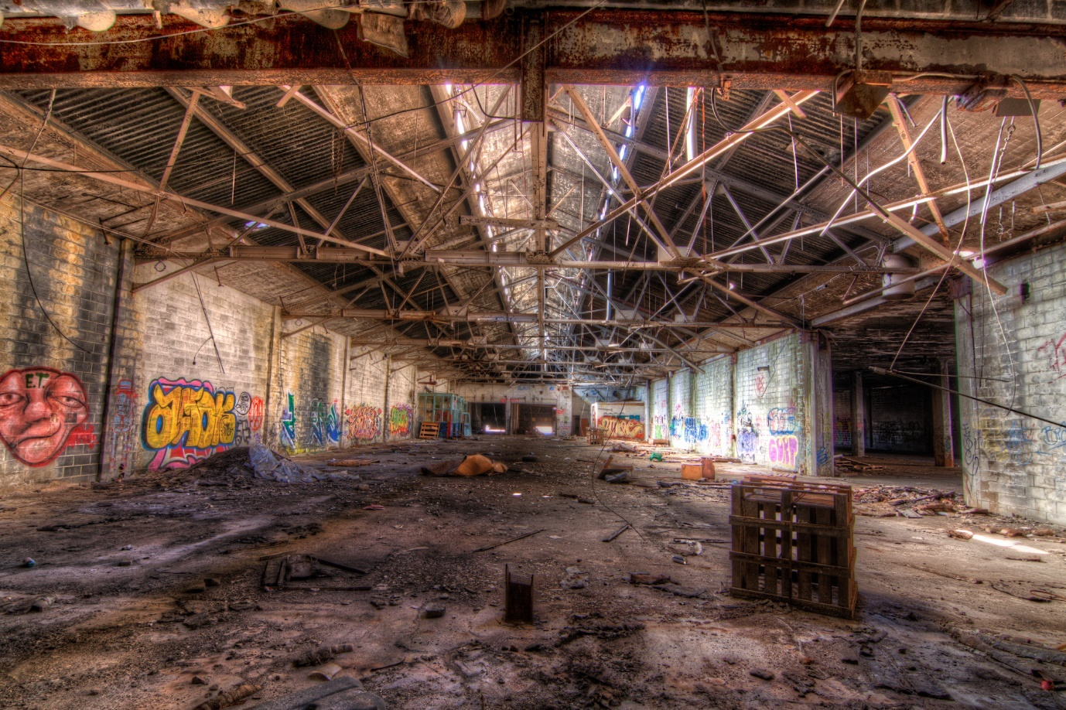](https://www.google.co.uk/url?sa=i&rct=j&q=&esrc=s&source=images&cd=&cad=rja&uact=8&ved=0ahUKEwik7vzI5qHTAhUBbxQKHVEIB9cQjRwIBw&url=https://www.pinterest.com/pin/464152305321039033/&psig=AFQjCNHfmjTu-QwQBPl_A-pWGxCSbeKw4Q&ust=1492181704946293)

http://farzinphoto.com/wp-content/uploads/2012/03/IMG_3045_HDR.jpg

**Graffiti & The Colour Scheme**

The picture above shows a variety of colours within the graffiti. The dark colours are the base of the photo regarding the beige and brown flooring, and the green mouldy walls. However, surrounding the inner dark colours are bright graffiti paintings. The colours consist of Red, Yellow, Blue, Green, Orange and Purple. These colours will be added to the ‘gameshow’ colours scheme.

**The Brightness**

As mentioned previously, the dark colours will shine brighter than the light colours, as I do not wish the focus to be on the light colours. The dark colours will be the main colour scheme, while the bright colours will shine dim into the environment. The audience will notice the bright colours, but they will not be the focus. The bright colours used in this colour pallet will be repeated in the ‘gameshow’ colour pallet, however, will be much brighter.

[](https://www.google.co.uk/url?sa=i&rct=j&q=&esrc=s&source=images&cd=&cad=rja&uact=8&ved=0ahUKEwjf8NT66aHTAhUJXRQKHcHVBB8QjRwIBw&url=http://www.creativecolorschemes.com/resources/free-color-schemes/warm-color-scheme.shtml&bvm=bv.152180690,d.ZGg&psig=AFQjCNGNML4159rjoOMMncsFXYFOT4QqXg&ust=1492186464282194)

http://www.creativecolorschemes.com/resources/free-color-schemes/images/warm-web-palettes.png

**The Dark Colour Scheme**

The colours which will create the abandoned warehouse atmosphere are beige, green and brown. When the narrators are in Limbo, the darker colour scheme will be bolder, with hints of colour representing the graffiti and involving the ‘gameshow’ colour scheme.

[](https://www.google.co.uk/url?sa=i&rct=j&q=&esrc=s&source=images&cd=&cad=rja&uact=8&ved=0ahUKEwiostLR9KPTAhVGuxQKHbdbAJQQjRwIBw&url=http://www.ebay.co.uk/itm/Dark-Green-Solid-Plain-100-Cotton-Fabric-Makower-Spectrum-Quilting-Sewing-/141416484654&psig=AFQjCNExB_3BtyQZg-sniOyjqkDTtRFImg&ust=1492258059148155)[](https://www.google.co.uk/url?sa=i&rct=j&q=&esrc=s&source=images&cd=&cad=rja&uact=8&ved=0ahUKEwiMgZmu9KPTAhUC6RQKHdneD_cQjRwIBw&url=https://www.minoli.co.uk/tiles/iconic-beige/&psig=AFQjCNGVcSi6oo9Ths1l94e7OhPc65mONA&ust=1492257991094960)

[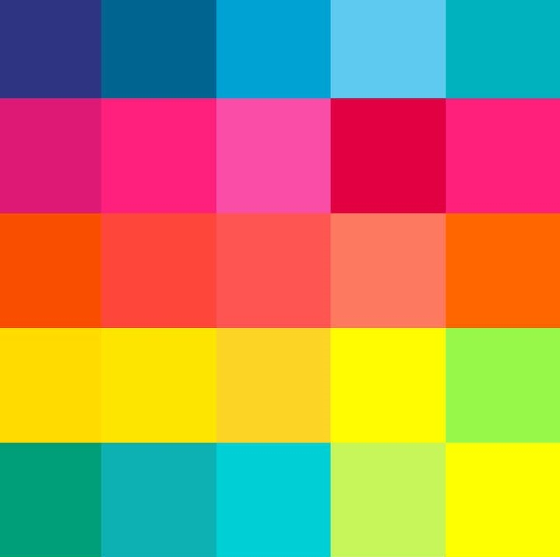](https://www.google.co.uk/url?sa=i&rct=j&q=&esrc=s&source=images&cd=&cad=rja&uact=8&ved=0ahUKEwjT6dSS7aHTAhVFOxQKHdVzB1QQjRwIBw&url=http://artdecostyle.ca/art-deco-style-blog/art-deco-colours&bvm=bv.152180690,d.ZGg&psig=AFQjCNF1vMGcJ4nc-eKbM88_f4Pc0WojxQ&ust=1492187329173644)

https://static1.squarespace.com/static/56e36f751d07c0743d1e142f/570aae482fe131a6e201c3a3/570aae49b654f9c14fbc8cca/1460317874621/bold+and+bright+colour+scheme.jpg

**The Bright Colour Scheme**

The bright colour scheme as mentioned previously will reflect the graffiti on the abandoned warehouse walls, and will be the same colour scheme during the ‘gameshow’ scenes. The Bright colour scheme will consist of: blue, pink, red, orange, yellow and green.

[](https://www.google.co.uk/url?sa=i&rct=j&q=&esrc=s&source=images&cd=&cad=rja&uact=8&ved=0ahUKEwiwzuuE2qvTAhWMVRQKHYg7AQAQjRwIBw&url=http://www.gizmodo.co.uk/2016/12/brace-yourselves-the-next-iphone-might-come-in-red/&bvm=bv.152479541,d.ZGg&psig=AFQjCNE4EMcYI40T108wJk8OCxb6i8Fqng&ust=1492525736210113)[](https://www.google.co.uk/url?sa=i&rct=j&q=&esrc=s&source=images&cd=&cad=rja&uact=8&ved=0ahUKEwi34trO2avTAhXKOxQKHZg2AaAQjRwIBw&url=https://www.pinterest.com/noefire/think-in-hot-pink/&bvm=bv.152479541,d.ZGg&psig=AFQjCNH4Zq2P0k5DaQjQzCLHnKka7-QkiA&ust=1492525688647748)[](https://www.google.co.uk/url?sa=i&rct=j&q=&esrc=s&source=images&cd=&cad=rja&uact=8&ved=0ahUKEwinuNOP2avTAhUJaxQKHSnwABQQjRwIBw&url=https://en.wikipedia.org/wiki/Blue&psig=AFQjCNERTcQT-sULn6b04JMvVuFSKxthDA&ust=1492525551316933)

[](https://www.google.co.uk/url?sa=i&rct=j&q=&esrc=s&source=images&cd=&cad=rja&uact=8&ved=0ahUKEwiasOnz2qvTAhVDxRQKHUJeBwYQjRwIBw&url=https://itunes.apple.com/gb/app/yellow-make-new-friends/id1038653883?mt%3D8&bvm=bv.152479541,d.ZGg&psig=AFQjCNG_RKyfPFL1hvOz8w3OGjw2HwELPQ&ust=1492526036196020)[](https://www.google.co.uk/url?sa=i&rct=j&q=&esrc=s&source=images&cd=&cad=rja&uact=8&ved=0ahUKEwio8Mit2qvTAhWMPRQKHeKiBE0QjRwIBw&url=http://symbolism.wikia.com/wiki/Orange_(Color)&bvm=bv.152479541,d.ZGg&psig=AFQjCNGB1Nb0jf22g8aFsejlCQf-2to_lA&ust=1492525886527861)

[](https://www.google.co.uk/url?sa=i&rct=j&q=&esrc=s&source=images&cd=&cad=rja&uact=8&ved=0ahUKEwivssqb26vTAhXFxRQKHSKeAxQQjRwIBw&url=http://www.playbuzz.com/ebonymbaker10/which-monsters-university-frat-house-are-you-in&bvm=bv.152479541,d.ZGg&psig=AFQjCNGSkVwVpcquL7gbw6Oefsrhk9cpbw&ust=1492526114203962)