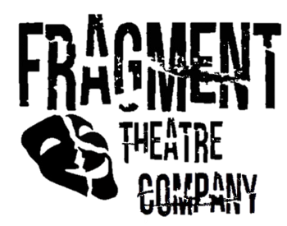
Press Release

CONTACT:
Emily Nixon
Marketing Manager
Fragment Theatre Company
079 846 5X2 XX
fragment-theatre@hotmail.com

For Immediate Release
2nd May 2017
Fragment Theatre Company presents Exit This Way
“It’s bigger, it’s sexier, it’s the new and improved Wheel of Escapism”
Fragment Theatre Company announces its debut performance of Exit This Way at the Lincoln Performing Arts Centre on the 19th May 2017.
Exit This Way is a postdramatic performance exploring the world of escapism. This meta-physical production blurs the world of the character and the actor to highlight the dangers of escapism. As the two presenters Brodie and Rob try to create the ultimate escapism gameshow things begin to get out of hand as cake, colanders, feather boas, and money collide on the stage. Fragment Theatre Company use tongue in cheek comedy to show the sadistic side to Escapism in a new and fun way.
Exit This Way takes place in limbo where the two presenters Rob and Brodie act like God-like characters to create their ultimate escape! They do this by taking enjoyment in the failure of the other four protagonist’s lives. As the other characters try to escape from the problems of daily life through food, reading, childhood and music they ultimately discover that it will not work. This visceral performance uses projection, dance, lighting and homemade props to create a fun show about a serious subject.
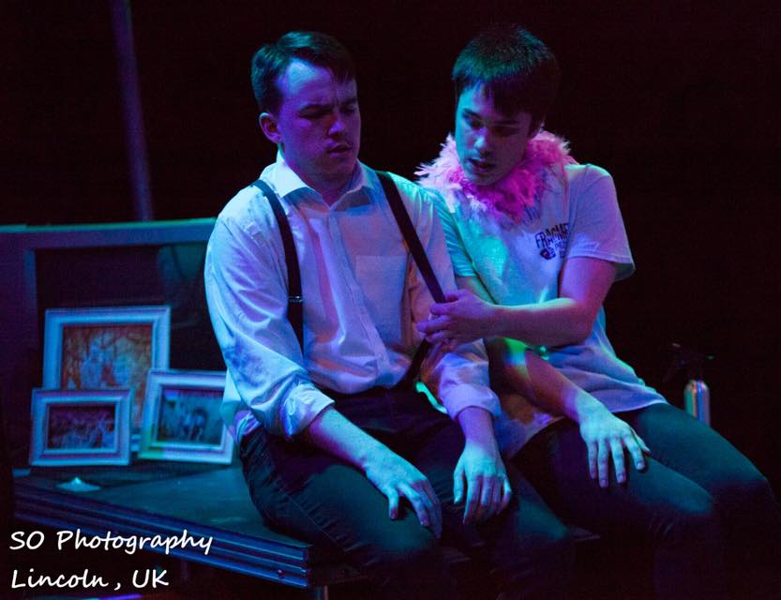
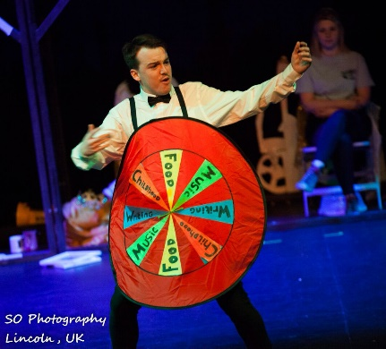
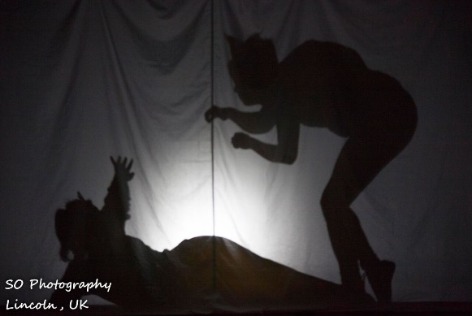
Note to editors: Fragment Theatre Company are a group of ten third year students from the University of Lincoln.

