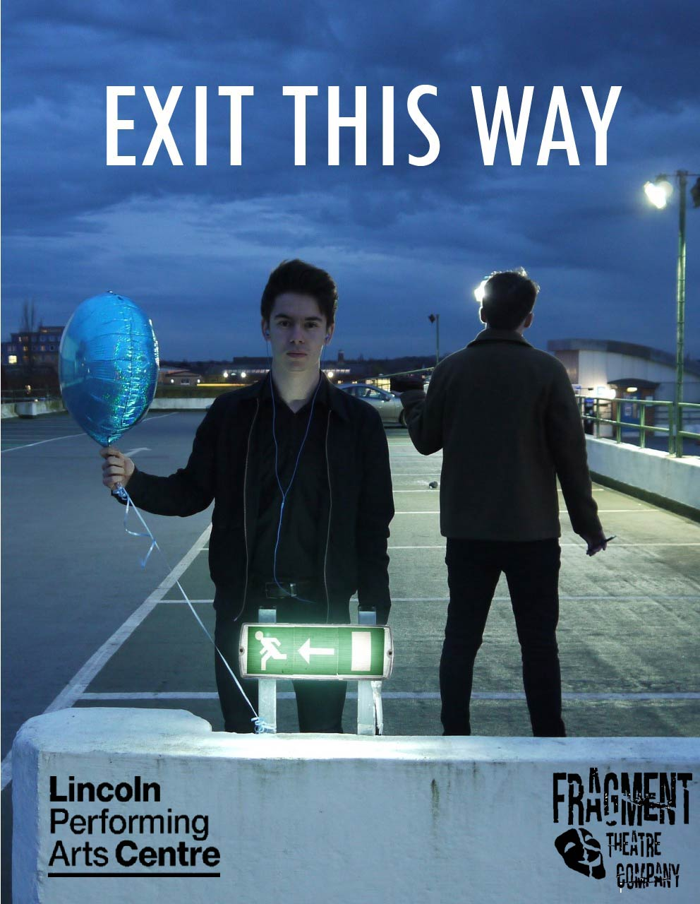
Special thanks too…

Mark Brewer- for your support and guidance

Bethany Jewkes @Bethanydesignsthings

Molly Rickards- for giving us your time and patience

Jack Kirsop- for your Media and filming skills

Workwear express

Lincoln Performing Arts Centre Technical Team

Lincoln Performing Arts Centre Front of House Team

And finally

To all those who have Donated and made this show possible!

Hope you enjoy the show
Fragment Theatre Company x

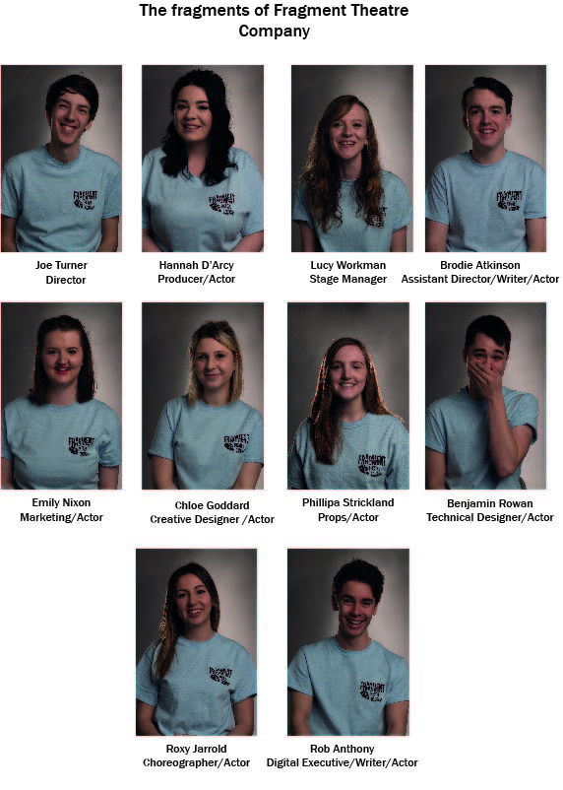
Director's Note

Good evening and welcome to Exit This Way. The very title of the show gives a basic instruction to leave, depart, get out… In short, to escape. This is what tonight’s show is all about: Human nature, the problems we face and how, when the going gets tough, we sometimes need to get away.
Why Escapism? As a group, we are aware of all the issues that are currently prominent in the world at the moment including political disturbance, cultural differences and economic turmoil. These problems are something which we as a cast felt, and continue to feel, overwhelmed by. Rather than adding to the ongoing list of shows tackling these issues head on I came to the conclusion that we were going to use this turmoil as context and instead focus on how we, and ultimately you as individuals, get away.
The reason I felt that escapism would be an interesting area for exploration is that there is such variety and no two people escape the same way. Between the ten members of the company we all escape in different ways. Whilst some of us escape through reading and fantasy, others enjoy escaping through food or through partying with friends. By showing this variety, my hope is that our audience will be able to connect to at least one of the escapes shown, making the show relatable to as many of the audience members of possible. After all, ‘that’s the true beauty of escapism’.
Our purpose in creating Exit This Way is to demonstrate to all of the members of the audience that having a means of departing your life is OK for a short period of time. It is a temporary answer, a momentary escape. It is not however a permanent solution to your problems and this show serves as a warning and as a reminder of this fact. Please sit back, relax and enjoy what I, and the rest of Fragment Theatre Company, hope you find an entertaining, thought provoking and meaningful piece of theatre.
Thank you for coming,
Joe Turner – Director of Exit This Way

