About Fragment Theatre Company
Exit This Way
Marketing Pack

Fragment Theatre Company is a group of ten students studying at the University of Lincoln. We formed in 2017 and have come together to create theatre that focuses on the smaller stories rather than the big news of the world.

Our Mission:
To explore the reality of the fragmented, the everyday and the individual.

Our Manifesto:
We are an emerging theatre company, based in Lincoln.
We are inspired by the humanistic elements of life and the potential these type of issues have upon people, on a global scale.
Our objective is to create innovative, stimulating and engaging theatre, by using the issues which fragment society to examine the personal and the individual.
As a company, we believe that within every big picture there are a thousand fragments, each more unique than the last.
Our work encompasses inter-medial elements combined with narration and a make shift aesthetic, inviting audiences to discover, explore, and be inspired.
We are playful, we are professional, and we are quirky.
We are Fragment Theatre Company.

We speak to: Someone. Anyone. Everyone.

About ‘Exit This Way’
Directed by Joe Turner
Assisted by Brodie Atkinson
Produced by Hannah D’Arcy
Stage Management by Lucy Workman
Written by Brodie Atkinson and Rob Anthony
Costume and Set Design by Chloe Goddard
Sound and Lights by Ben Rowan
Props by Phillipa Strickland
Choreography by Roxy Jarrold
Marketing by Emily Nixon

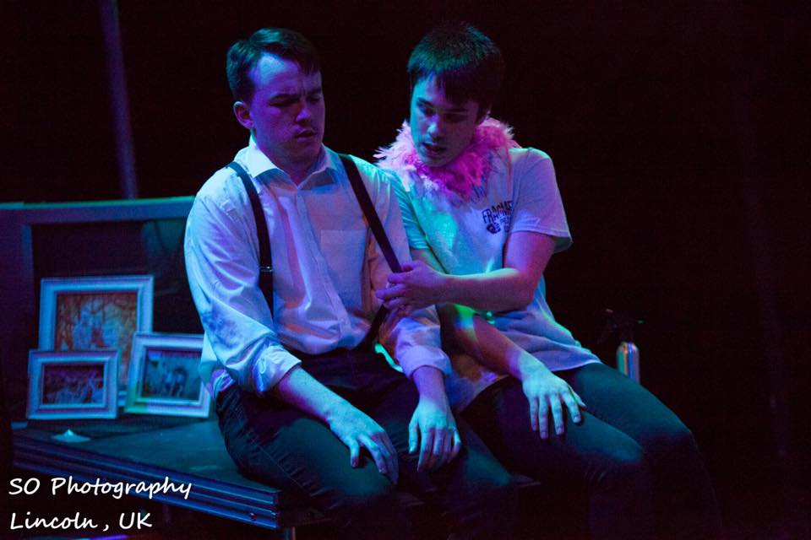
Two presenters, six contestants and four ways to escape: food, childhood, reading and music. Exit This Way shows an aspect of our lives that often is ignored, but plays a key part in getting through day to day life: escapism. Through the use of metaphysical and DIY theatre, escapism is presented in a new light, one that makes you realise how much you actually rely on it. Our tongue in cheek portrayal of this world shows how there is more escaping to reality and the dangers in not facing your problems.
Brochure Copy

150 Words
“Think of escapism like sugar or salt, you can sprinkle it on top of your life to make it better but too much will ruin the whole thing”
Ever tried to get away from everyday life? Or wanted to feel free for a few brief seconds? Exit This Way is a meta- theatrical exploration of an aspect of our lives that goes unnoticed but plays a huge role. From the worries of having to face your future to the struggle of finding that perfect body, Exit This Way shows that there can be both positives and negatives to escaping your problems and provides a place in which together we can get away.
‘Fragment Theatre Company’s’ debut show presents the journey of escapism, and the effects it has on you, the everyday person.
80 Words// Shortened
“Think of escapism like sugar or salt, you can sprinkle it on top of your life to make it better but too much will ruin the whole thing”
Ever tried to get away from everyday life? Or wanted to feel free for a few minutes? Exit This Way is a meta- theatrical exploration of an aspect of our lives that goes unnoticed.
‘Fragment Theatre Company’ presents the journey of escapism, and the effects it has on you, the everyday person.
40 Words// Tagline
“Think of escapism like sugar or salt, you can sprinkle it on top of your life to make it better but too much will ruin the whole thing”
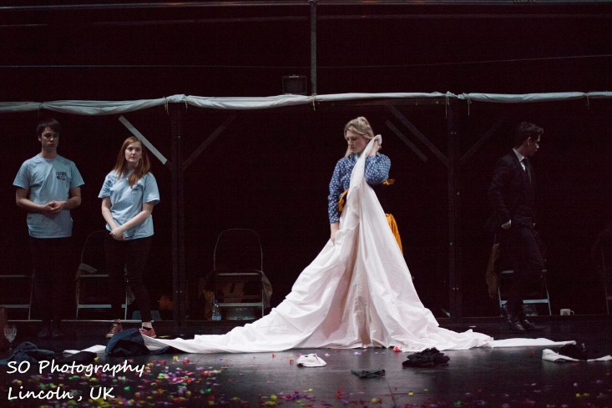
‘Fragment Theatre Company’s’ presents the journey of escapism, and the effects it has on the everyday person.
Target Audience
Our core audience for Exit This Way are:
- Students of the University of Lincoln.
- Ages 16+ Community (due to strong language).
- Those who live in Lincoln.
- People interested in the issue of escapism.
- Those interested in Post-dramatic and Meta-physical theatre.

Unique Selling Point
As a Theatre Company we take serious issues and present them in a comical way, which still deals with the seriousness but in a light hearted manner.
We ensure to do this through tongue in cheek sense of comedy and with our unique and homemade aesthetic mainly through the use of props.

Box Office Information

Company Name: Fragment Theatre Company
Title of Show: Exit This Way
Running Time: Approx. 60 Minutes
Age: 16+
Interval: N/A

Online Resources
fragmenttheatrecompany

@FragmentTheatreCompany

@fragmentTC
Contact Information
Email Address: fragment-theatre@hotmail.com
Website/ Blog: http://fragmenttc.blogs.lincoln.ac.uk/
Instagram: https://www.instagram.com/fragmenttheatrecompany/
Facebook: https://www.facebook.com/FragmentTheatreCompany/
Twitter: https://twitter.com/fragmenttc?lang=en-gb

