Design 10: Romance Design

[](http://www.google.co.uk/url?sa=i&rct=j&q=&esrc=s&source=images&cd=&cad=rja&uact=8&ved=0ahUKEwj7s4vZnNfTAhWL1RoKHYIEDeoQjRwIBw&url=http://www.scoopify.org/roses-are-red-violets-are-blue-poems/&psig=AFQjCNFLx6tHTOk-Qsc9lD_RLRtr2DLZTw&ust=1494020967694032)

http://www.scoopify.org/wp-content/uploads/2016/05/Roses-Are-Red-Violets-Are-Blue-love-Poems1-Scoopify.png

**Colour Scheme**

As previously mentioned, the colours I will be using in this colour palette are the colours mentioned in the love poem; rose red and violet blue. This will create a dream like romantic setting where Alice can dream about her successful relationship with her long time crush. The environment created will be flirtatious and relaxing in order to support Alice in her flirting, and obviously to set the mood for the audience.

**Valentine’s Day Poem**

In the writing chapter based on Alice, there is a romantic story Alice tells the audience about a boy, and how she has trouble confessing her attraction to her crush. This gave me the idea to base the lighting colour scheme on the famous valentine’s poem, “roses are red, and violets are blue”. This design will create a romantic aura, in order to give Alice to confidence to confess her love. The colour used will be Rose Red and Violet Blue.

[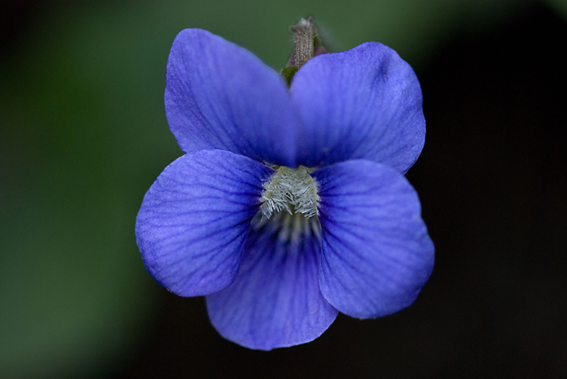](https://www.google.co.uk/url?sa=i&rct=j&q=&esrc=s&source=images&cd=&cad=rja&uact=8&ved=0ahUKEwjrmOH4ndfTAhXK1BoKHcEnBMIQjRwIBw&url=https://philipschwarzphotography.wordpress.com/2015/06/16/common-blue-violets-everywhere/&psig=AFQjCNGsDvdoWJZv5sEsildonZIJk5rktg&ust=1494021480416422)[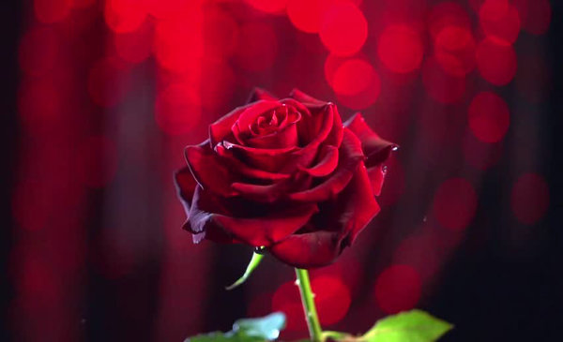](https://www.google.co.uk/url?sa=i&rct=j&q=&esrc=s&source=images&cd=&cad=rja&uact=8&ved=0ahUKEwjf6d73mtfTAhUGPxoKHcCkDIUQjRwIBw&url=https://www.brandingstrategyinsider.com/2017/04/3-ways-brands-can-ignite-romance.html&psig=AFQjCNGZZhUcJZG-KIGe_ekD72AZzcMyYg&ust=1494020660429156)

https://philipschwarzphotography.files.wordpress.com/2012/04/blue-violet-08-83-110.jpg

https://www.brandingstrategyinsider.com/images/2017/04/How-Brands-Can-Ignite-Romance.jpg

[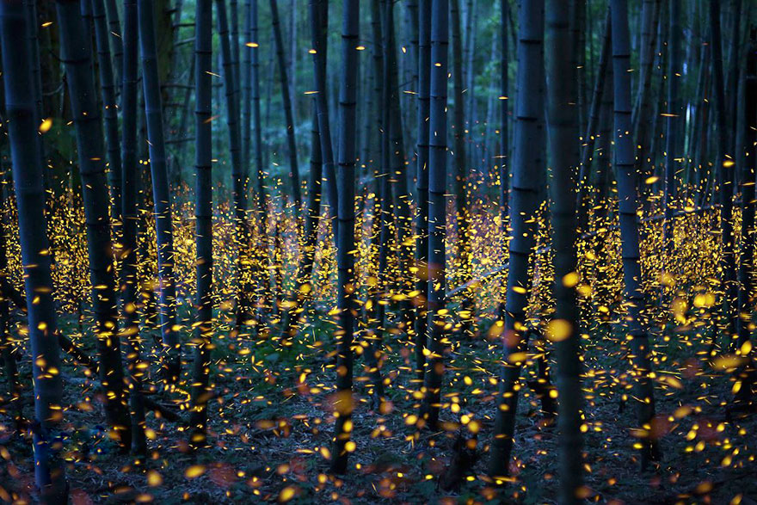](http://www.google.co.uk/url?sa=i&rct=j&q=&esrc=s&source=images&cd=&cad=rja&uact=8&ved=0ahUKEwjf4bKIn9fTAhVGAxoKHaa_BfQQjRwIBw&url=http://www.boredpanda.com/fireflies-long-exposure-photography-2016-japan/&psig=AFQjCNFWdE9QuJMWVuK0RdJ4_VT-1YbI8A&ust=1494021780709935)

http://static.boredpanda.com/blog/wp-content/uploads/2016/07/fireflies-long-exposure-photography-2016-japan-19.jpg

**Warm & Romantic**

As mentioned before, the idea behind this palette is to create a warm romantic colour scheme. In order to do this, I will combine the images above of the red rose, the blue violet and the firefly’s, and create a dreamlike world we all wish to visit with our loved ones. The Rose Red is to provide a flirtatious aura, the violet blue to include a hint on insecurity and finally, sun gold to highlight the gaps between her dream world and reality, and to add warmth.

**Fireflies**

Nothing says romance like fireflies. Alongside the rose red and violet blue pallet, I wish the add hints of sun yellow into the palette, to allow some warmth and safety within the design. The rose red and violet blue will support the creation of a dream like world, and the hints of sun yellow will provide gaps from her dream life and reality; as seen in Design 9: Fantasy Design with the white hints beaming through the sun.

[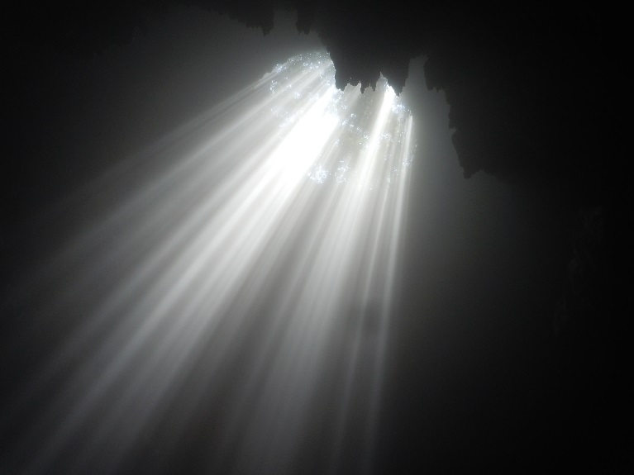](https://www.google.co.uk/url?sa=i&rct=j&q=&esrc=s&source=images&cd=&cad=rja&uact=8&ved=0ahUKEwjLoabcp9fTAhXCVRQKHdeZBKEQjRwIBw&url=https://www.pinterest.com/ManiacalTeddy/photoshop-effectsresources/&psig=AFQjCNF4wbULoCZYP2YuzOqCbvRPkbWRvA&ust=1494024116985185)

[](https://www.google.co.uk/url?sa=i&rct=j&q=&esrc=s&source=images&cd=&cad=rja&uact=8&ved=0ahUKEwiJsr3an9fTAhUF6xoKHUinAkIQjRwIBw&url=https://www.pinterest.com/pin/226235581253122566/&psig=AFQjCNGK_6xebHJALrls57a77WKvlrQj5Q&ust=1494021968801737)

https://s-media-cache-ak0.pinimg.com/originals/6c/9d/5e/6c9d5e5e71f07b7cff0d215ca0910175.jpg

[](http://www.google.co.uk/url?sa=i&rct=j&q=&esrc=s&source=images&cd=&cad=rja&uact=8&ved=0ahUKEwiqx63ooNfTAhUDthoKHUdBBpcQjRwIBw&url=http://www.wampstore.com/store/Vallejo-Game-Color-Sun-Yellow&psig=AFQjCNHIXFlPU07Xr1GY2iz8JlLmB9p88A&ust=1494022268707107)[](http://www.google.co.uk/url?sa=i&rct=j&q=&esrc=s&source=images&cd=&cad=rja&uact=8&ved=0ahUKEwigq8j8n9fTAhXEcBoKHdoVCNIQjRwIBw&url=http://purplebluecolor.facts.co/&psig=AFQjCNES6EHH3HQJGO_cF24LTBxF8EMFuA&ust=1494022037301897)

**Romance Palette**

This palette, like the Fantasy Design will be a general wash. The colours used will be Rose Red, Violet Blue and Sun Yellow. As stated above, the Rose Red is to provide a flirtatious aura, the violet blue is to include a hint on insecurity and finally, sun gold to highlight the gaps between her dream world and reality, and to add warmth and safety into the surroundings. The Sun Yellow will shine brighter than the other 2 colours, however, it will not overpower them. All 3 colours will blend on stage rather than basing an individual colour to different sections of the stage as seen in the Fantasy Design. Within the scene, a spotlight lights up Ben, and the spotlight will shine a white colour to resemble the cheesy heaven beam as if he had been chosen by god himself.