Design 2: Limbo

http://themuse.jezebel.com/heres-new-art-from-the-elle-fanning-fashion-horror-film-1781631150
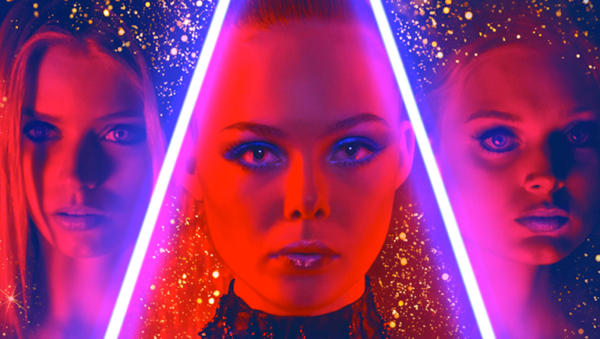

The Neon Bars

The Neon Demon, a film by Nicolas Winding Refn is my main inspiration. The colours used throughout almost allow the viewer to have an insight on reality, and the ‘perfect world’. The Neon Bars give me the idea of a portal to the dream world. The portal allows the characters to escape from their everyday lives.
The Pink and Red Background

The Red and Pink inspires me to create a dream like world, filled with beautiful colours which almost looks magical, creating this mythical atmosphere. I love colour, and I aim to correct a colourful world which will support the audience in relaxing and escaping with the characters.

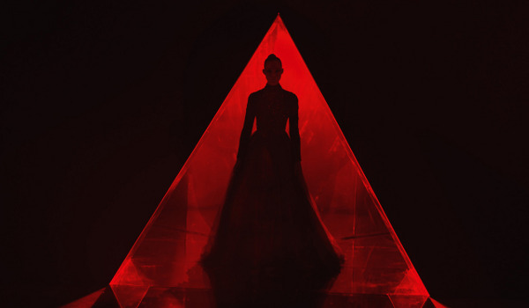
http://www.razorfine.com/movie-reviews/the-neon-demon/

The Silhouette

The silhouette in the picture above is the main focus. She grabs the attention of the audience. I aim to have the narrator walk through this ‘portal’ grabbing the attention from the audience so he/she is able to take them along the journey through the production.
The Opening Passage

Similar to the description in ‘The Neon Bars’. The red triangle represents the passage between the real world, and the dream like world. Once the characters have stepped through this passage, they are introduced to their own version of a perfect world, and escaping their everyday lives.

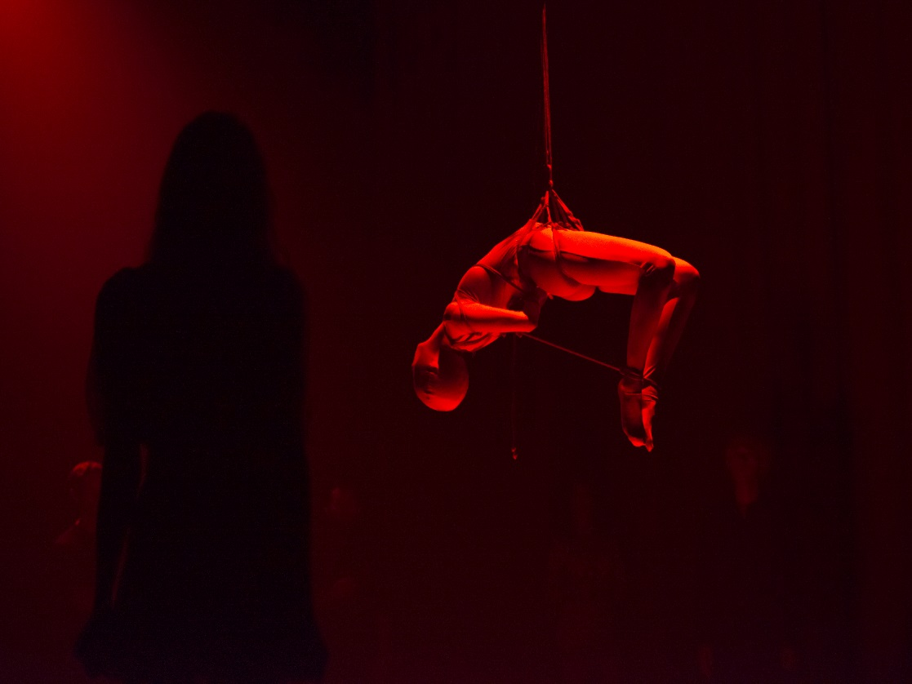

https://amuse-i-d.vice.com/the-neon-demon/

The Dark Surroundings

The Dark surroundings, meaning the darkness we are actually escaping from. Like The Dark Figure & Lit Figure, the dark parts of the stage represents the darkness in our reality. The characters aim to stay in the lit areas so they are truly able to escape their reality.
The Dark Figure & Lit Figure

What is the Dark Figure? Is it someone or something we are escaping from? And is the lit figure the individual trying to escape? This inspires me to create a different levels of brightness on stage. I imagine some figures to be lit, and some in the dark given the audience the freedom to create their own demons. The individuals who are lit are the character escaping, where the individuals in the dark are the reason they are escaping.

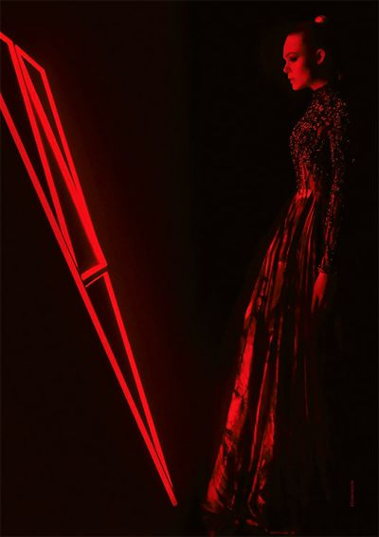

https://consequenceofsound.files.wordpress.com/2016/06/the-neon-demon-vertical.jpg?quality=80&w=400&h=567

The Escaper

The Escaper, half lit and half in the dark representing him/her leaving his/hers darkness and entering his/hers light.
The Portal to the Real/Dream World

This is very similar to ‘The Neon Bars’ and ‘The Opening Passage’. I am currently in the process of deciding whether or not to have a physical portal on stage, inspire by the one above, or just have a philosophical portal which the audience can imagine.

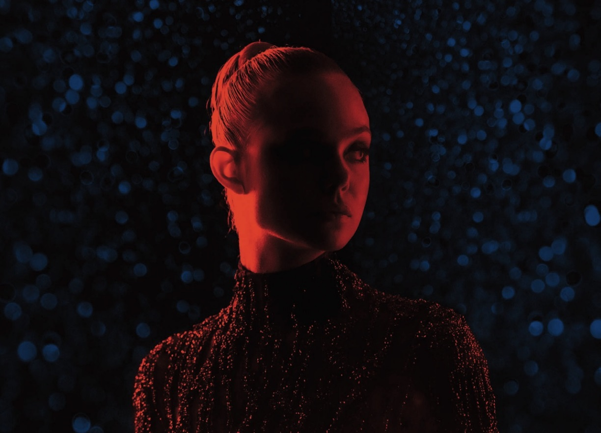
http://www.slantmagazine.com/assets/house/26065/festivals_neondemon.jpg
The Individual
Like ‘The Escaper’, the individual above is half lit, half the dark, unsure what her true reality is or which reality she prefers. This inspired me to instead light up the whole body on stage throughout the production, at times only light up parts of the body given of this identified silhouette affect.

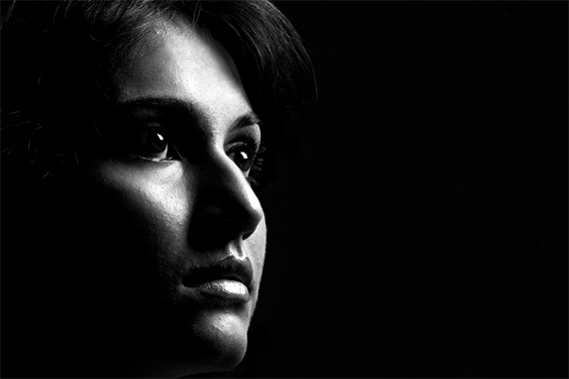
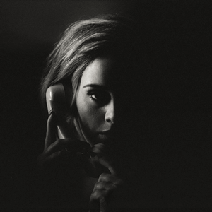

https://upload.wikimedia.org/wikipedia/en/8/85/Adele_-_Hello_(Official_Single_Cover).png
https://s-media-cache-ak0.pinimg.com/originals/74/54/82/74548270b61481acf66533faad39f6ca.jpg
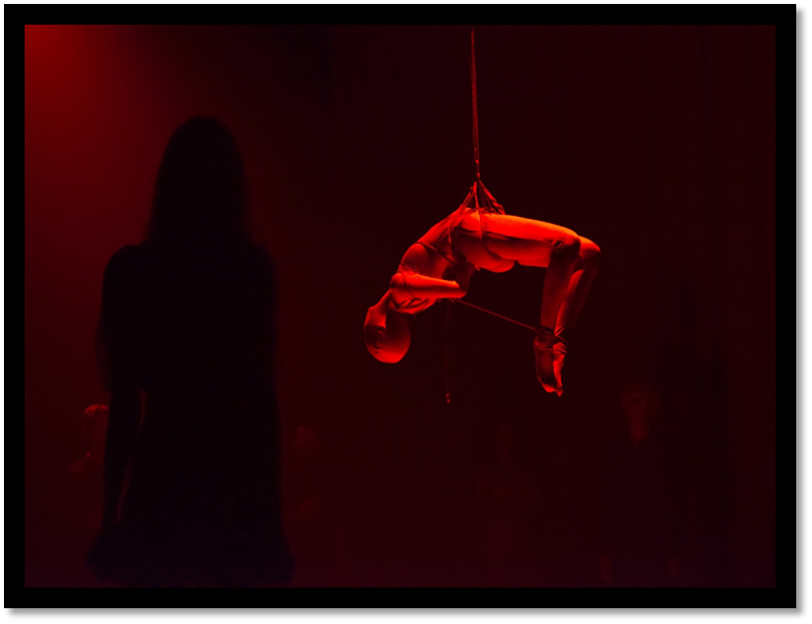

https://amuse-i-d.vice.com/the-neon-demon/

https://www.youtube.com/watch?v=NZYmgZSf6KY

The YouTube link above is a scene from The Neon Demon when the 4 girls go to a club. The scene consists of a red strobe light flashing throughout the scene, and in the middle of the room is a figure which represents the perfect individual. The camera then goes on the show the girls faces as they watch this figure in the middle of the room and their faces begin to change expression as they compare themselves to each other. The figure then begins to mould into someone who is trapped as seen in the image above, to represent the dangers of self-obsession and beauty, and you become trapped in your own routine and habits.
Inspired by this, once the audience are seated, a strobe light begins to flash on stage as the presenter (the individual in the middle of the room) comes out on stage preparing to draw in these characters to the dream world. The characters are scattered around the auditorium almost hypnotized by this unidentified figure, and continue to follow him onto the stage, and through the portal into the dream world. This then begins the story of the ‘childhood scene’ as the strobe light will stop flashing and the lights will light up the setting belonging to the first scene.
https://www.youtube.com/watch?v=VngeoOy-nFs

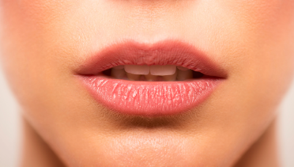
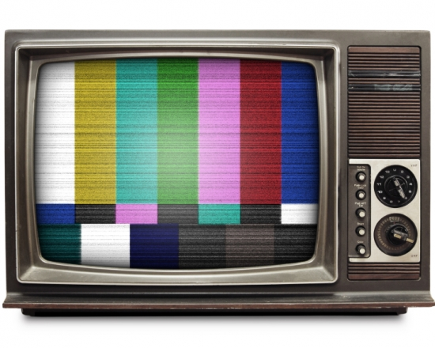
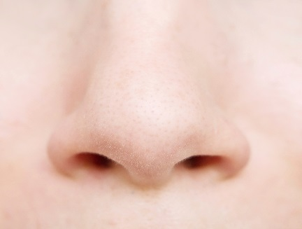
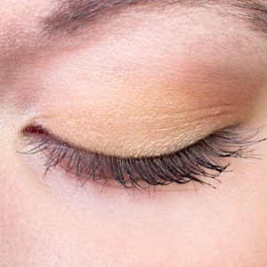
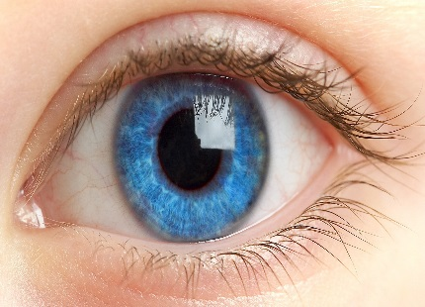
Faces/Static on Screen – The Blur between Reality & the Fantasy Land

Throughout the open house section, while the audience are entering the auditorium, I have an image of parts of a person’s face (both male and female) representing the person who is escaping. This audience will NOT understand this meaning as they first enter, but begin to understand the meaning behind the faces throughout the final production.

