[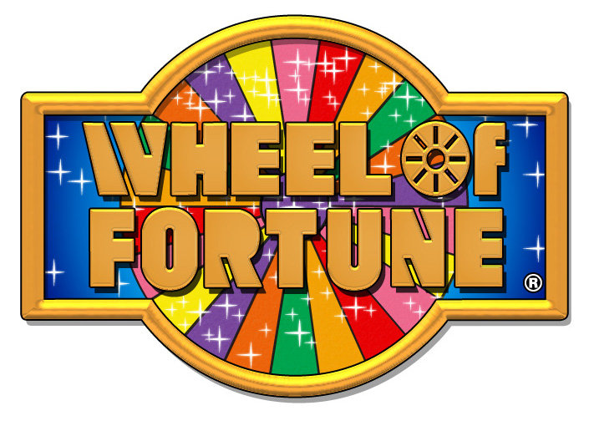](https://www.google.co.uk/url?sa=i&rct=j&q=&esrc=s&source=images&cd=&cad=rja&uact=8&ved=0ahUKEwi0vLfwnLPTAhWJvhQKHYdaBD4QjRwIBw&url=http://www.marinemaxvacations.com/about/news/marinemax-vacations-provides-wheel-fortune-prize/&psig=AFQjCNGzuw7IiinJFC2GzVudR4SBpvgwiA&ust=1492783936714969)Design 3: Gameshow Design

http://www.marinemaxvacations.com/wp-content/uploads/2015/01/wheel_of_fortune_logo__08678.jpg

**Wheel of Fortune**

Wheel of Fortune is the gameshow this design is inspired from. The colours in the logo are bright vibrant colour visually pleasing to the audience. The colours seen in the logo consist of Blue, Yellow, Pink, Red, Sunset Orange, Green, Orange and Purple, and these colours are the colours I will be using in the final colour scheme.

[](https://www.google.co.uk/url?sa=i&rct=j&q=&esrc=s&source=images&cd=&cad=rja&uact=8&ved=0ahUKEwinuNOP2avTAhUJaxQKHSnwABQQjRwIBw&url=https://en.wikipedia.org/wiki/Blue&psig=AFQjCNERTcQT-sULn6b04JMvVuFSKxthDA&ust=1492525551316933)

[](https://www.google.co.uk/url?sa=i&rct=j&q=&esrc=s&source=images&cd=&cad=rja&uact=8&ved=0ahUKEwio8Mit2qvTAhWMPRQKHeKiBE0QjRwIBw&url=http://symbolism.wikia.com/wiki/Orange_(Color)&bvm=bv.152479541,d.ZGg&psig=AFQjCNGB1Nb0jf22g8aFsejlCQf-2to_lA&ust=1492525886527861)[](https://www.google.co.uk/url?sa=i&rct=j&q=&esrc=s&source=images&cd=&cad=rja&uact=8&ved=0ahUKEwi34trO2avTAhXKOxQKHZg2AaAQjRwIBw&url=https://www.pinterest.com/noefire/think-in-hot-pink/&bvm=bv.152479541,d.ZGg&psig=AFQjCNH4Zq2P0k5DaQjQzCLHnKka7-QkiA&ust=1492525688647748)[](https://www.google.co.uk/url?sa=i&rct=j&q=&esrc=s&source=images&cd=&cad=rja&uact=8&ved=0ahUKEwiwzuuE2qvTAhWMVRQKHYg7AQAQjRwIBw&url=http://www.gizmodo.co.uk/2016/12/brace-yourselves-the-next-iphone-might-come-in-red/&bvm=bv.152479541,d.ZGg&psig=AFQjCNE4EMcYI40T108wJk8OCxb6i8Fqng&ust=1492525736210113)[](https://www.google.co.uk/url?sa=i&rct=j&q=&esrc=s&source=images&cd=&cad=rja&uact=8&ved=0ahUKEwivssqb26vTAhXFxRQKHSKeAxQQjRwIBw&url=http://www.playbuzz.com/ebonymbaker10/which-monsters-university-frat-house-are-you-in&bvm=bv.152479541,d.ZGg&psig=AFQjCNGSkVwVpcquL7gbw6Oefsrhk9cpbw&ust=1492526114203962)[](https://www.google.co.uk/url?sa=i&rct=j&q=&esrc=s&source=images&cd=&cad=rja&uact=8&ved=0ahUKEwiasOnz2qvTAhVDxRQKHUJeBwYQjRwIBw&url=https://itunes.apple.com/gb/app/yellow-make-new-friends/id1038653883?mt%3D8&bvm=bv.152479541,d.ZGg&psig=AFQjCNG_RKyfPFL1hvOz8w3OGjw2HwELPQ&ust=1492526036196020)

[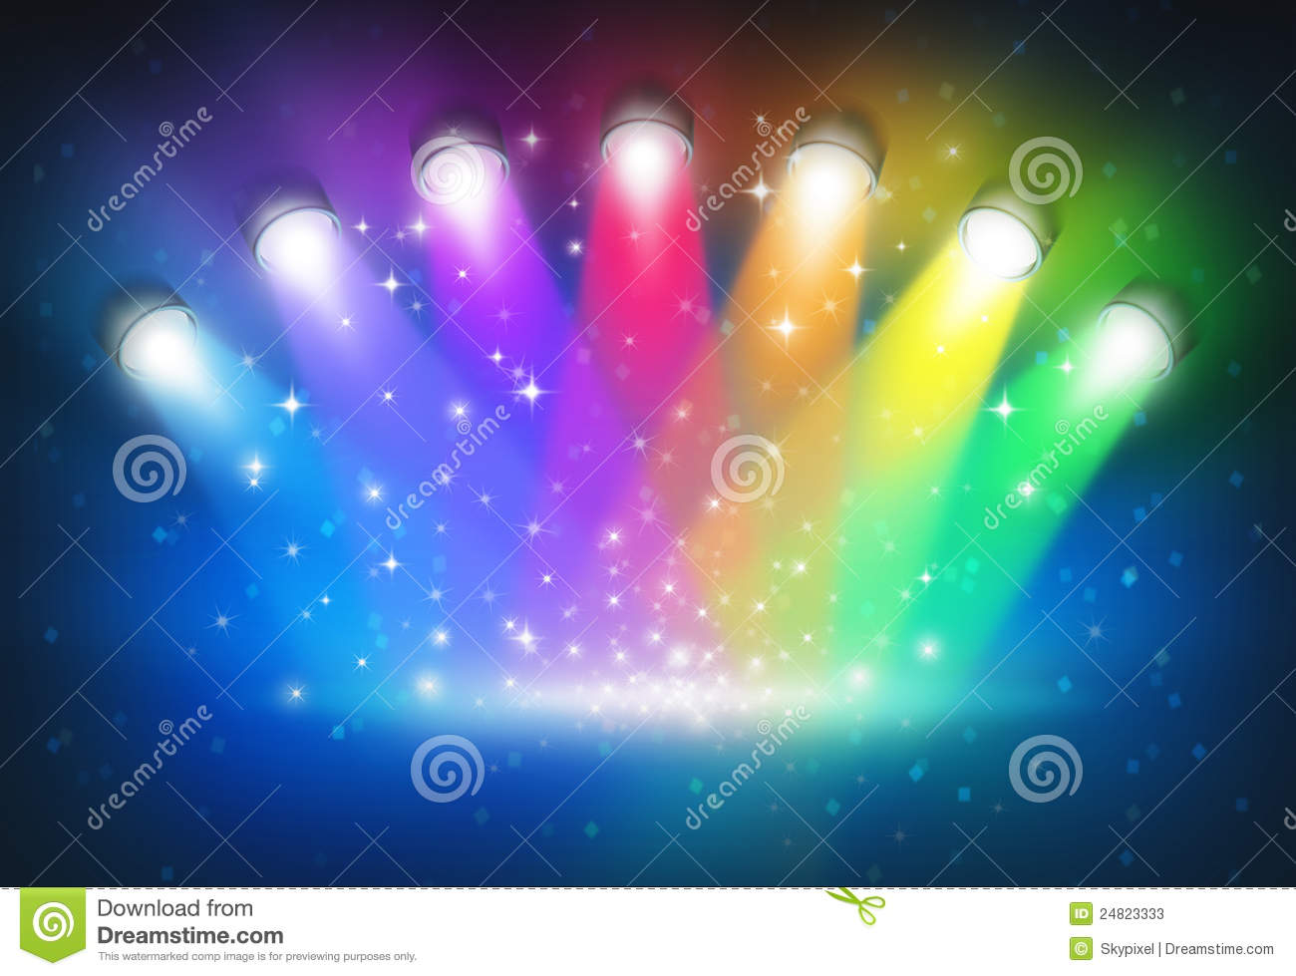](https://www.google.co.uk/url?sa=i&rct=j&q=&esrc=s&source=images&cd=&cad=rja&uact=8&ved=0ahUKEwjD7KS4lbPTAhXGRhQKHTHOD3cQjRwIBw&url=https://www.dreamstime.com/stock-photos-spotlights-rainbow-colours-image24823333&psig=AFQjCNEMjYlG2TxZTzgYj9kbp0VzcYjzSg&ust=1492782263764572)

https://thumbs.dreamstime.com/z/spotlights-rainbow-colours-24823333.jpg

**Lighting Movements**

As stated, the colour scheme will be overdramatic, meaning that I inspire to have flashing spotlights which move around the auditorium and flashing lights like an old-school disco. This design needs to be energetic and exciting to give the audience the impression they are watching a real-life gameshow. I would like to create a similar effect, the lights in the above image does in the final production.

**Colour Scheme**

The colour scheme for the gameshow design was mentioned previously in the ‘Narrators Opening Speech Mouldboard’. The colour scheme will consist of bright vibrant colours such as: blue, pink, red, orange, yellow and green. The colour scheme will aim to match a similar over the top image we would see on a real-life gameshow. The overall atmosphere will be visually pleasing.

[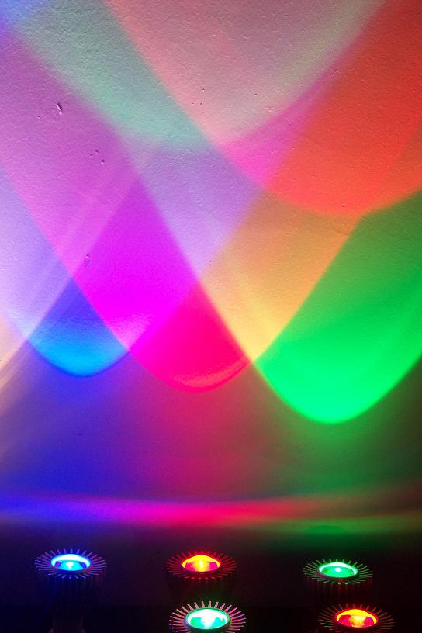](https://www.google.co.uk/url?sa=i&rct=j&q=&esrc=s&source=images&cd=&cad=rja&uact=8&ved=0ahUKEwis3obbmLPTAhVFVhQKHeuqA1YQjRwIBw&url=http://bricolux.blogspot.com/2013/02/decorar-iluminando-hoy-en-dia-la.html&psig=AFQjCNEMjYlG2TxZTzgYj9kbp0VzcYjzSg&ust=1492782263764572)

http://image.made-in-china.com/2f0j00FeMagnOInRzl/E27-3W-Single-Color-LED-Spotlight-Bulb.jpg

**Floor Lights**

As seen in the picture above, there is a set a floor lights reflecting several different colours on a blank back drop. This inspires me to create the same effect by having several lights on the floor facing up reflecting colours onto the back drop and in the scaffolding. Once again, this colours schemes aim is to be as overdramatic and energetic, making it visually pleasing for the audiences. This means I aim to have lights facing down onto the stage, into the audience and lights facing up from the stage onto the roof. The more lights, the better. The colours I will use in the floor lights will be: Orange, Green and Blue light the image above.

[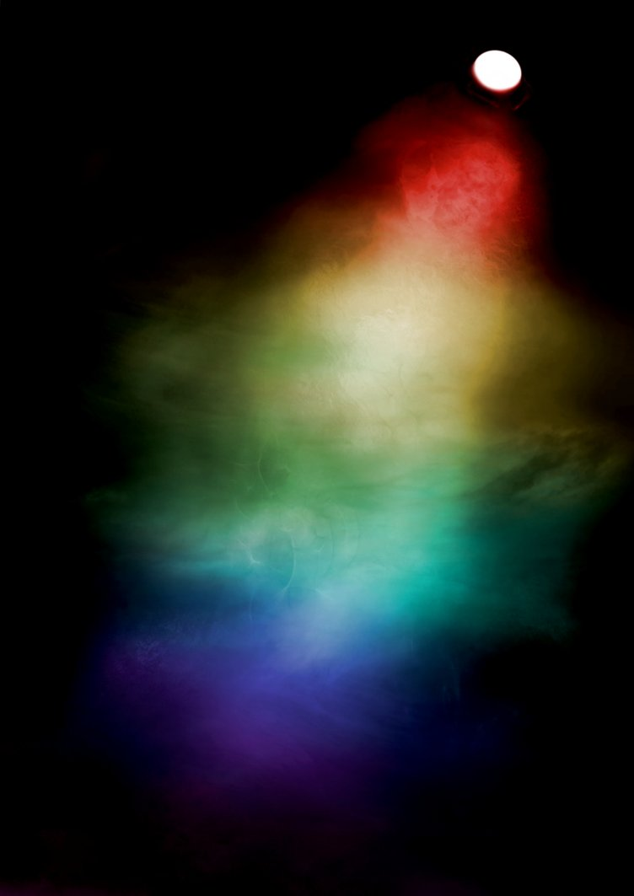](https://www.google.co.uk/url?sa=i&rct=j&q=&esrc=s&source=images&cd=&cad=rja&uact=8&ved=0ahUKEwjzsoDxmrPTAhUHvhQKHQdTBFAQjRwIBw&url=http://greyfaerie4.deviantart.com/art/Rainbow-Spotlight-stock-background-349826512&psig=AFQjCNEMjYlG2TxZTzgYj9kbp0VzcYjzSg&ust=1492782263764572)

**Smoke Machine**

In the picture above the light shines through some mist created from a smoke machine. This inspires me to have a smoke machine on when the introduction music begins to play, and the narrators are preparing to appear on stage. The smoke machine will help with the build-up and contribute to help with the over the top effect. In the image above the light shine different colours in the mist, and with the lighting shining from the floor up, this will help with creating a similar effect. This will make the stage and lighting look more creative and visually pleasing from the audiences point of view.

http://image.made-in-china.com/2f0j00FeMagnOInRzl/E27-3W-Single-Color-LED-Spotlight-Bulb.jpg

[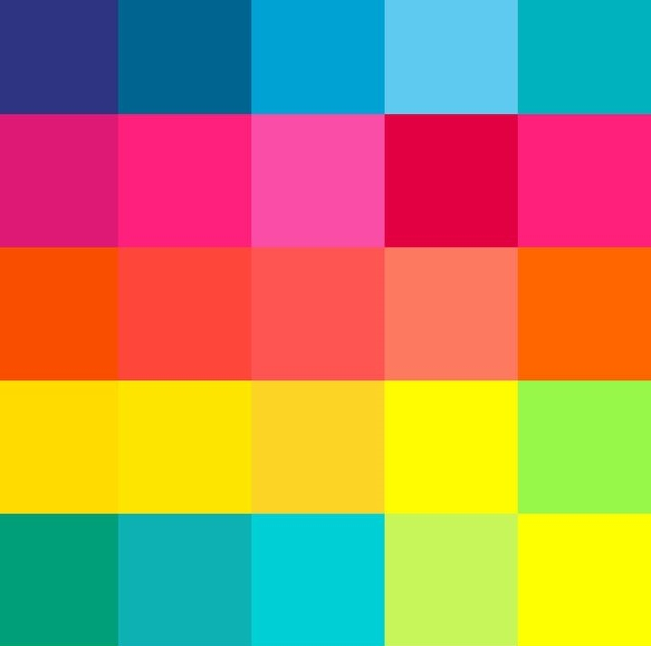](https://www.google.co.uk/url?sa=i&rct=j&q=&esrc=s&source=images&cd=&cad=rja&uact=8&ved=0ahUKEwjT6dSS7aHTAhVFOxQKHdVzB1QQjRwIBw&url=http://artdecostyle.ca/art-deco-style-blog/art-deco-colours&bvm=bv.152180690,d.ZGg&psig=AFQjCNF1vMGcJ4nc-eKbM88_f4Pc0WojxQ&ust=1492187329173644)

https://static1.squarespace.com/static/56e36f751d07c0743d1e142f/570aae482fe131a6e201c3a3/570aae49b654f9c14fbc8cca/1460317874621/bold+and+bright+colour+scheme.jpg

[](https://www.google.co.uk/url?sa=i&rct=j&q=&esrc=s&source=images&cd=&cad=rja&uact=8&ved=0ahUKEwiasOnz2qvTAhVDxRQKHUJeBwYQjRwIBw&url=https://itunes.apple.com/gb/app/yellow-make-new-friends/id1038653883?mt%3D8&bvm=bv.152479541,d.ZGg&psig=AFQjCNG_RKyfPFL1hvOz8w3OGjw2HwELPQ&ust=1492526036196020)[](https://www.google.co.uk/url?sa=i&rct=j&q=&esrc=s&source=images&cd=&cad=rja&uact=8&ved=0ahUKEwio8Mit2qvTAhWMPRQKHeKiBE0QjRwIBw&url=http://symbolism.wikia.com/wiki/Orange_(Color)&bvm=bv.152479541,d.ZGg&psig=AFQjCNGB1Nb0jf22g8aFsejlCQf-2to_lA&ust=1492525886527861)[](https://www.google.co.uk/url?sa=i&rct=j&q=&esrc=s&source=images&cd=&cad=rja&uact=8&ved=0ahUKEwinuNOP2avTAhUJaxQKHSnwABQQjRwIBw&url=https://en.wikipedia.org/wiki/Blue&psig=AFQjCNERTcQT-sULn6b04JMvVuFSKxthDA&ust=1492525551316933)

[](https://www.google.co.uk/url?sa=i&rct=j&q=&esrc=s&source=images&cd=&cad=rja&uact=8&ved=0ahUKEwiwzuuE2qvTAhWMVRQKHYg7AQAQjRwIBw&url=http://www.gizmodo.co.uk/2016/12/brace-yourselves-the-next-iphone-might-come-in-red/&bvm=bv.152479541,d.ZGg&psig=AFQjCNE4EMcYI40T108wJk8OCxb6i8Fqng&ust=1492525736210113)[](https://www.google.co.uk/url?sa=i&rct=j&q=&esrc=s&source=images&cd=&cad=rja&uact=8&ved=0ahUKEwivssqb26vTAhXFxRQKHSKeAxQQjRwIBw&url=http://www.playbuzz.com/ebonymbaker10/which-monsters-university-frat-house-are-you-in&bvm=bv.152479541,d.ZGg&psig=AFQjCNGSkVwVpcquL7gbw6Oefsrhk9cpbw&ust=1492526114203962)[](https://www.google.co.uk/url?sa=i&rct=j&q=&esrc=s&source=images&cd=&cad=rja&uact=8&ved=0ahUKEwi34trO2avTAhXKOxQKHZg2AaAQjRwIBw&url=https://www.pinterest.com/noefire/think-in-hot-pink/&bvm=bv.152479541,d.ZGg&psig=AFQjCNH4Zq2P0k5DaQjQzCLHnKka7-QkiA&ust=1492525688647748)

**The Bright Colour Scheme (Copy)**

The bright colour scheme as mentioned previously in Design 1 will consist of several bright colours such as: blue, pink, red, orange, yellow and green. This link in with the Wheel of Fortune Logo we have used as our main inspiration.