Design 4: Childhood

https://fthmb.tqn.com/I7KOyiWKLHQjlX94jDztCtEuQ7A=/1280x854/filters:no_upscale():fill(transparent,1)/about/apt-furnishing-155302401-resized-56a33d025f9b58b7d0d11085.jpg

[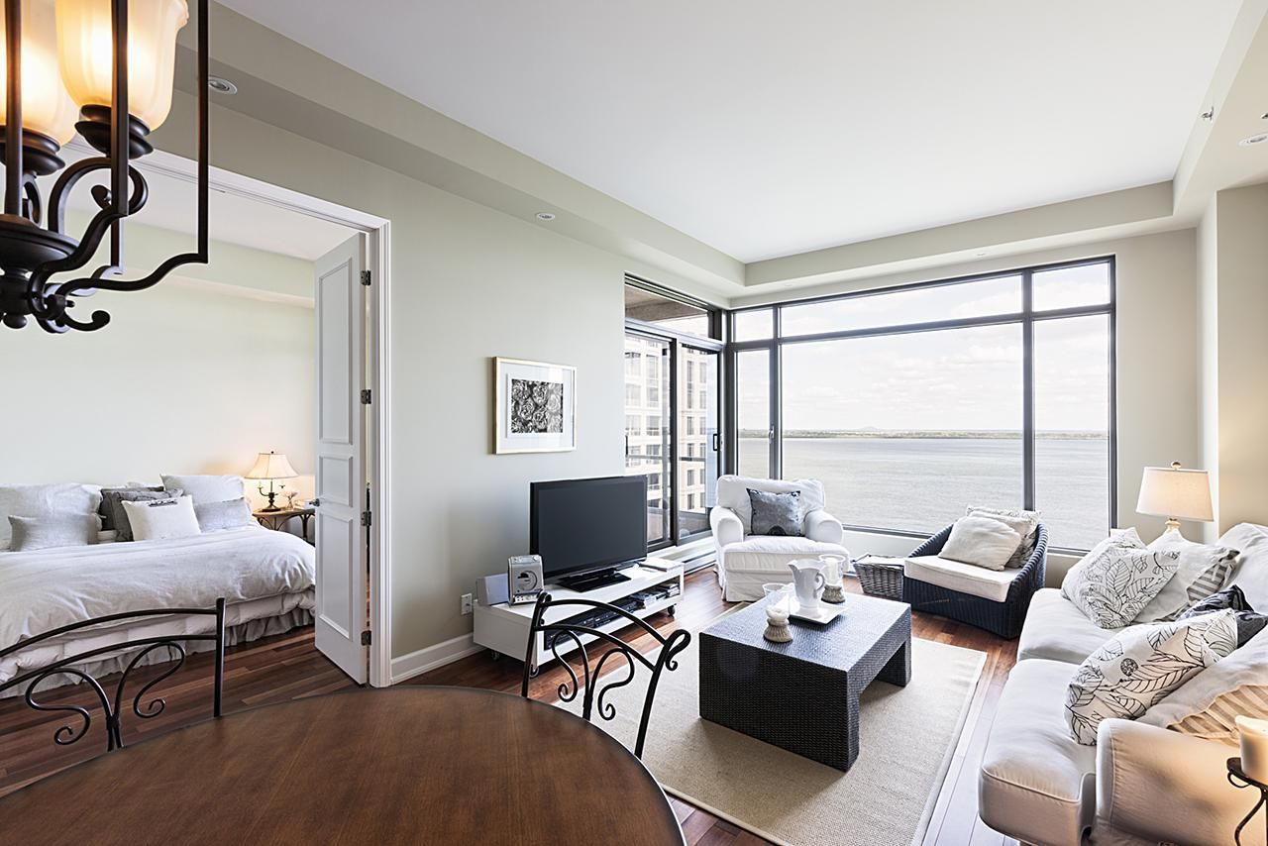](https://www.google.co.uk/url?sa=i&rct=j&q=&esrc=s&source=images&cd=&cad=rja&uact=8&ved=0ahUKEwjnu9KQsbDTAhWDVRQKHTNXDiwQjRwIBw&url=https://www.thespruce.com/what-is-an-apartment-155733&psig=AFQjCNHSZ0no-AzydUL17LxG2TXW0CGO8A&ust=1492686592830773)

**Colour Scheme**

As mentioned previously, the colour scheme will be as natural as possible. The colours used during the opening section will be a warm lighting with hints of white. The warm lighting will symbolise lighting from a side lamp, and the white lighting to show the outdoor lighting shining through the windows.

**General Wash**

During the opening of the ‘Childhood’ scene, Laura takes the audience on a tour around her apartment. During this, the lighting will be a general wash to appear as realistic as possible. There will not be any additional colours shining through, the colour scheme will be basic to appear as naturalistic as possible.

[](https://www.google.co.uk/url?sa=i&rct=j&q=&esrc=s&source=images&cd=&cad=rja&uact=8&ved=0ahUKEwibp6fFw7DTAhVJ6RQKHa6VBdUQjRwIBw&url=https://www.pinterest.com/ahhainley/white-swatches/&psig=AFQjCNGC4Th7KwzObfbPu87pIHUeBWxkCQ&ust=1492691561122031)[](https://www.google.co.uk/url?sa=i&rct=j&q=&esrc=s&source=images&cd=&cad=rja&uact=8&ved=0ahUKEwisqM_5wrDTAhVDVhQKHZ9jCQ4QjRwIBw&url=http://www.am-beautix.co.uk/home/10-wheat-colour-splashback.html&psig=AFQjCNFBd4aDkyu9h48TYDyw7GTxZ-_haQ&ust=1492691396303601)[](https://www.google.co.uk/url?sa=i&rct=j&q=&esrc=s&source=images&cd=&cad=rja&uact=8&ved=0ahUKEwjFoZzdwrDTAhUKkRQKHYhVCvIQjRwIBw&url=https://www.pinterest.com/styleesascloset/colour-charts/&psig=AFQjCNEnxSX7Zo68RewSd248-6Ak8kCWag&ust=1492691344084902)[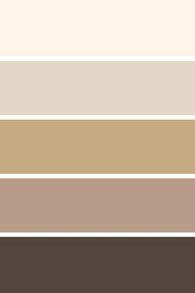](https://www.google.co.uk/url?sa=i&rct=j&q=&esrc=s&source=images&cd=&cad=rja&uact=8&ved=0ahUKEwip57ags7DTAhWEVxQKHSE_CqwQjRwIBw&url=https://www.pinterest.com/pin/89860955039427076/&psig=AFQjCNG6TIOB6ukqcGm4PCFw_lBDWeQiOg&ust=1492687173052416)

https://s-media-cache-ak0.pinimg.com/236x/41/c3/fe/41c3fec312a22f49149860a810f25c3e.jpg?noindex=1

**Neutral Shade**

The colour pallet for the opening scene will be neutral based shades. The reason for this as mentioned previously, it to create a more realistic setting. The other lighting designs in previous and future scenes are more energetic and less realistic, and because this colour scheme is more neutral, the audience will be able to understand which section is reality, and which section is ‘Limbo’. The same neutral colour scheme will continue throughout the whole childhood scene, however, when the shadow section begins, a flood light will light up the blanket from behind and will only shine two colours, straw and white. The lighting will change from straw to white when the narrators (Hannah & Emily) say, *“and one day, things changed”.*

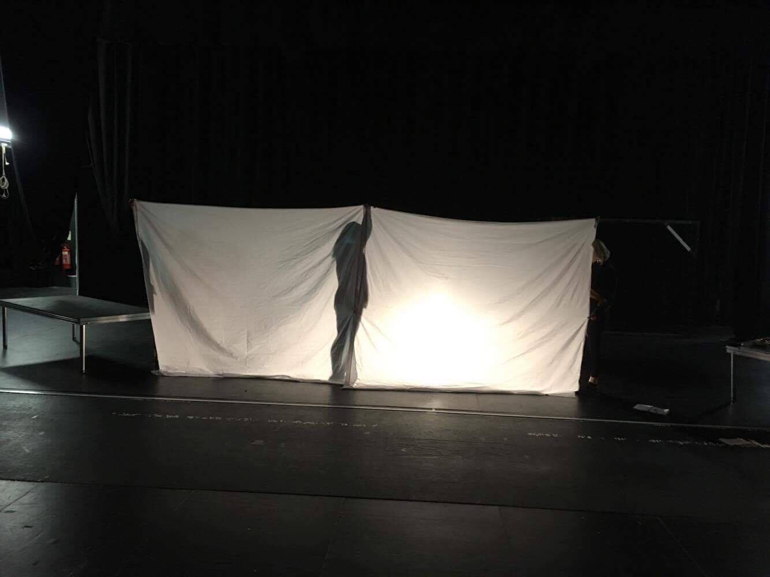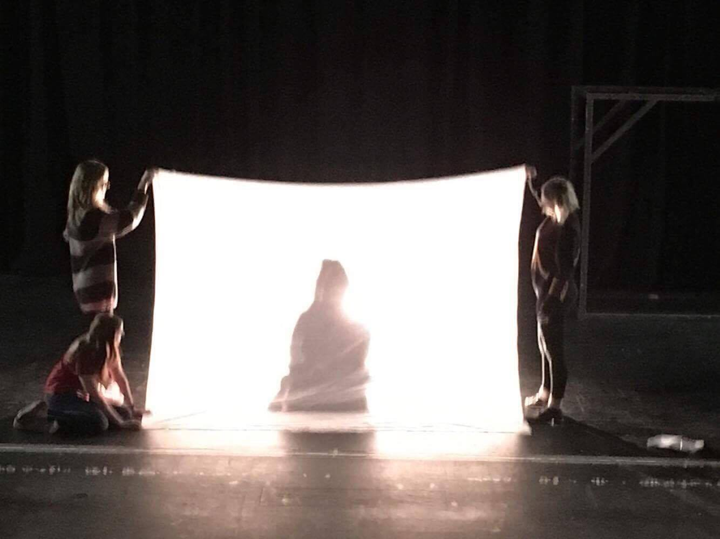

Example: 2

Example: 1

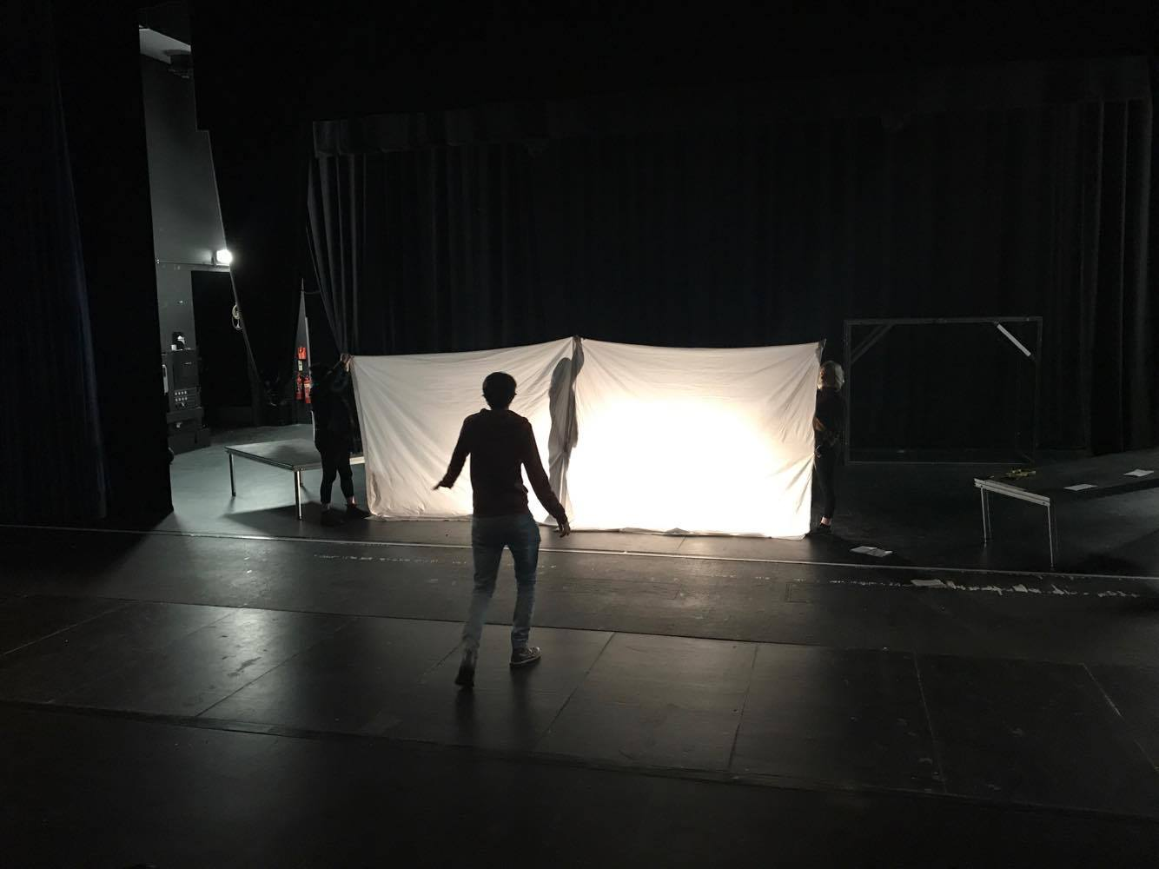

Example: 3

**Shadow Examples**

Above you can see 3 photos of the working in progress shadowing in the auditorium. The design is to have one flood light on behind the sheet throughout the telling the fairy tale, and 2 spot lights on the narrators (Hannah and Emily) as they tell the story. The stage will not be lit in the dangers of affecting the quality of the shadow. As mentioned previously, the flood light will shine 2 colours, white and straw, and the two spotlights which light up the narrators is yet to be confirmed. This will be confirmed during the tech rehearsal as it is a matter of which looks the best beside the flood light lighting change. I would also like to experiment with hints of baby blue and pink in the shadow lighting to resemble Laura’s childhood.

[](https://www.google.co.uk/url?sa=i&rct=j&q=&esrc=s&source=images&cd=&cad=rja&uact=8&ved=0ahUKEwjhiL3th7PTAhUKnRQKHRI8DmwQjRwIBw&url=http://www.yolandasaetern.com/&psig=AFQjCNFzZcMEzS01bWiwo03EIXUHmc4rQA&ust=1492778586615472)[](https://www.google.co.uk/url?sa=i&rct=j&q=&esrc=s&source=images&cd=&cad=rja&uact=8&ved=0ahUKEwjxppuAiLPTAhUGuhQKHTpMC-IQjRwIBw&url=https://www.pinterest.com/pin/48835977187092866/&psig=AFQjCNEjYjU68SybRz6QOMldRSsFeSB2sQ&ust=1492778658925358)[](https://www.google.co.uk/url?sa=i&rct=j&q=&esrc=s&source=images&cd=&cad=rja&uact=8&ved=0ahUKEwibp6fFw7DTAhVJ6RQKHa6VBdUQjRwIBw&url=https://www.pinterest.com/ahhainley/white-swatches/&psig=AFQjCNGC4Th7KwzObfbPu87pIHUeBWxkCQ&ust=1492691561122031)[](https://www.google.co.uk/url?sa=i&rct=j&q=&esrc=s&source=images&cd=&cad=rja&uact=8&ved=0ahUKEwisqM_5wrDTAhVDVhQKHZ9jCQ4QjRwIBw&url=http://www.am-beautix.co.uk/home/10-wheat-colour-splashback.html&psig=AFQjCNFBd4aDkyu9h48TYDyw7GTxZ-_haQ&ust=1492691396303601)