[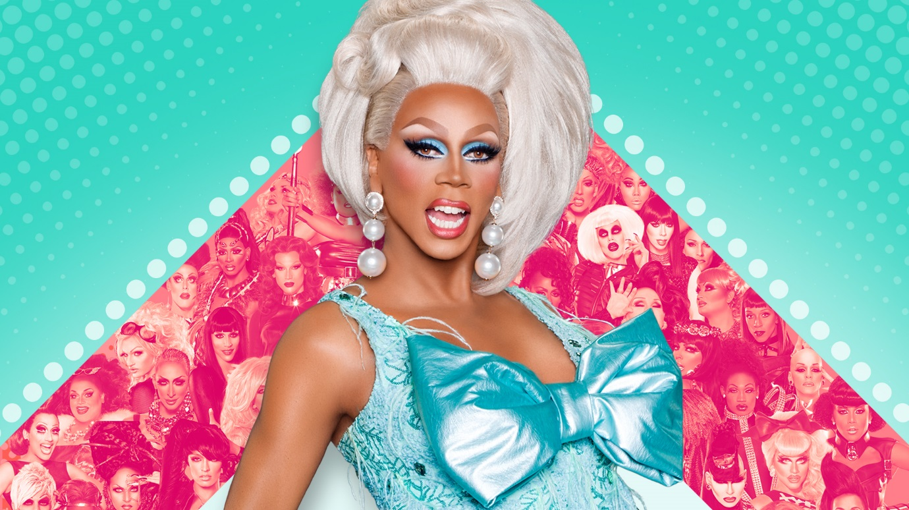](http://www.google.co.uk/url?sa=i&rct=j&q=&esrc=s&source=images&cd=&cad=rja&uact=8&ved=0ahUKEwi-4N-E-tvTAhVKChoKHURQCkgQjRwIBw&url=http://www.logotv.com/shows&psig=AFQjCNHJEiZgaHdM9KIVc7-4Rp0AX0S19w&ust=1494183630452689)Design 6: Drag Design

http://logoonline.mtvnimages.com/uri/mgid:file:gsp:entertainment-assets:/logo/shows/rpdr-s8-1920x1080.jpg

**Overdramatic Light Show**

The drag act lighting show will be extremely overdramatic and exciting, supporting the aim to create a visual pleasing design. The light show will be similar to the gameshow light show, however, this design will have different colours. The backlights on the floor used in the gameshow design will be involved in this project, and I would like to play with the idea of having a number of spotlights moving around the auditorium.

**Bright Colours**

The colours I would like to use in the Drag act design are bold bright pastel colours. As seen in the image above, the blue background and the pink dress are extremely bright, bold and visually pleasing and I would like to create a design which involved the same 3 words. The drag act is filled with full commitment, extreme sass and confidence and I wish the lighting to have the same traits. The main aim is to have the design visually pleasing.

[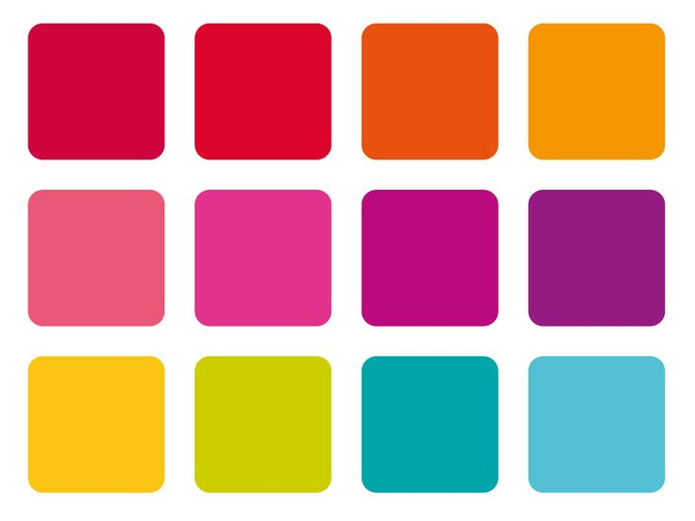](https://www.google.co.uk/url?sa=i&rct=j&q=&esrc=s&source=images&cd=&cad=rja&uact=8&ved=0ahUKEwjkneD2-9vTAhXIXRoKHajLD0gQjRwIBw&url=https://www.pinterest.com/explore/bright-color-palettes/&psig=AFQjCNGcNA2SbT5OLvwiReaGEqYqtw7qCA&ust=1494184140783975)

https://s-media-cache-ak0.pinimg.com/736x/a3/24/a2/a324a2d212dcfed3bad71f7f7e301965.jpg

**Bold Sharp Temperature**

The drag act is filled with full commitment, extreme sass and confidence and as previously mentioned, I wish to create a lighting design which shares the same traits. The temperature of the lights will be extremely bright and sharp, and the colours will blend of the stage. There will not be a set colour aimed to a certain section of the stage, as all the colours will blend, causing one dramatic, visually pleasing lighting display.

**Bright Pastel Colour Palette**

The palette above will be used in this lighting design. The colours in the drag show will consist of: hot pink, light blue, purple, orange and red. I would like to use orange and red to include a slight resemblance to the gameshow design, however, not a big one. As mentioned previously, I wish to include a number of moving spotlights around the auditorium, however, I would like to play with the different colours.

[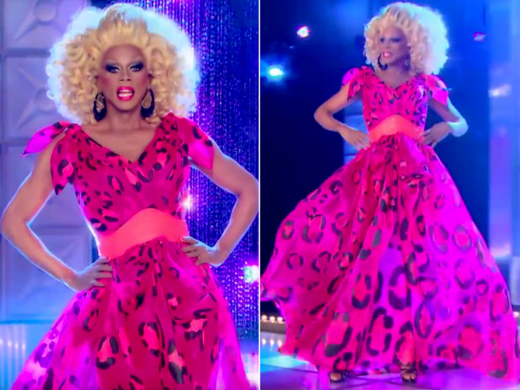](http://www.google.co.uk/url?sa=i&rct=j&q=&esrc=s&source=images&cd=&cad=rja&uact=8&ved=0ahUKEwiwyuf8_tvTAhWFthoKHYbwC04QjRwIBw&url=http://people.com/style/rupaul-best-fashion-drag-race-history&psig=AFQjCNFOQ7aDZlMz4Cada6H2V3zWjd87Kg&ust=1494184971656620)

https://peopledotcom.files.wordpress.com/2017/03/ru-paul-looks-7.jpg?w=669

**Sharp Light Movements**

As stated a number of times in this mood bored, the idea is to create an overdramatic, visually pleasing and bold lighting display. Regarding the moving spotlights which I wish to experiment with, I would like to have the lighting movement and changes to be quick and bold. This design is aimed to be exciting and a fast pace and with the lighting changing fast from washes of colour to lighting shows would support the overall aim.

**Bold Colours**

As mentioned previously, the colours used will be bright and bold. Seen in the image above, the hot pink dress shines brightly and boldly in front of the blue surroundings. On the technical day, I wish the play with the idea of certain moments of the act, the lights shine one colour at a time, highlighting the actor’s movement and elaborate costumes. As mentioned previously the colours will blend and certain moments of the act.

**B**