Design 7: Detective Design

[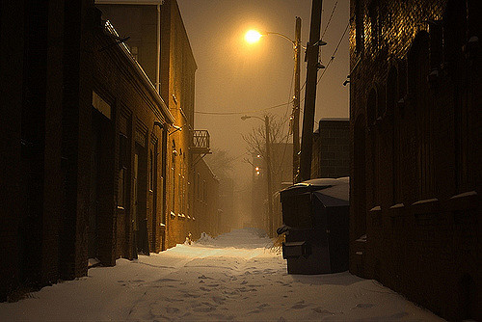](https://www.google.co.uk/url?sa=i&rct=j&q=&esrc=s&source=images&cd=&cad=rja&uact=8&ved=0ahUKEwjdue_Ny9jTAhWF5xoKHd-FC8IQjRwIBw&url=https://www.flickr.com/photos/21639834@N05/3938476115&psig=AFQjCNEqcME1z-OL8RNdJDFX_4v9zh2_iw&ust=1494068106381642)

https://c2.staticflickr.com/4/3463/3938476115_0d52472fef_z.jpg?zz=1

**Colour Scheme**

This colour scheme will consist of 2 colours, dark straw and a white spotlight. The atmosphere is designed to be creepy, but Alice the detective is brave enough to take us on the journey on solving a mysterious crime. The dark straw colour is to represent the one street lamp lighting the back alley, and the white spotlight will impersonate a helicopter spotlight which will be mentioned further on below the mood bored.

**Dark Alley**

In the writing section, Alice takes us on a journey through a number of different stories, the first being a detective on a crime scene. The environment I would like to create is one similar to a dark alley slightly lit by 1 street light. The image above shows a dark alley which has a creepy aura, yet one open to a number of adventures. The idea is to create a creepy atmosphere which Alice bravely faces and solves the crime.

[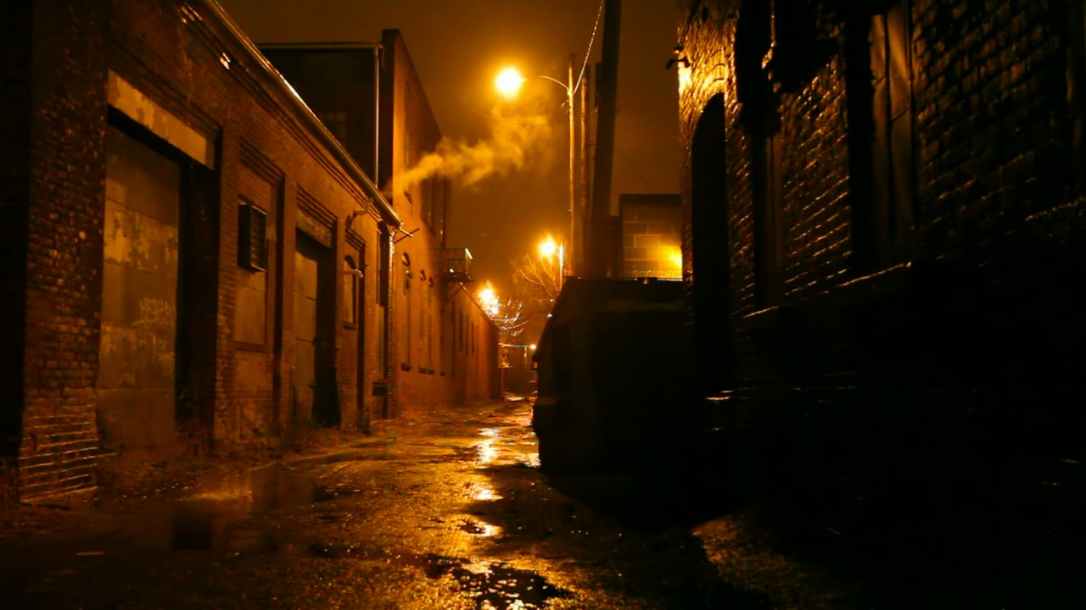](https://www.google.co.uk/url?sa=i&rct=j&q=&esrc=s&source=images&cd=&cad=rja&uact=8&ved=0ahUKEwjJkfLBzNjTAhWGWhQKHZlaDcYQjRwIBw&url=https://vimeo.com/97775176&psig=AFQjCNEqcME1z-OL8RNdJDFX_4v9zh2_iw&ust=1494068106381642)

http://i.vimeocdn.com/video/478266382_1280x720.jpg

**Light Temperature**

The temperature of the lighting will be dark and eerie. The surrounding stage will not be lit as if the surrounding stage is the part of the alley unable to be lit by the street lamp, and the main stage will be lit slightly with a dark straw wash to impersonate the one street lamp. This is used to support the creepy aura effect I want to create. The white spot light will shine brighter than the dark straw as the spotlight is coming from a helicopter above.

**General Wash**

This will be a general wash as the atmosphere is a realistic setting in Alice’s head. The lighting will not be as exciting as the other designs, using the gameshow lighting design as an example, as this palette is designed to create an atmosphere which is discomforting for both the character’s and the audience members, yet creepy enough to make Alice look brave as she investigates the crime scene alongside the other characters.

[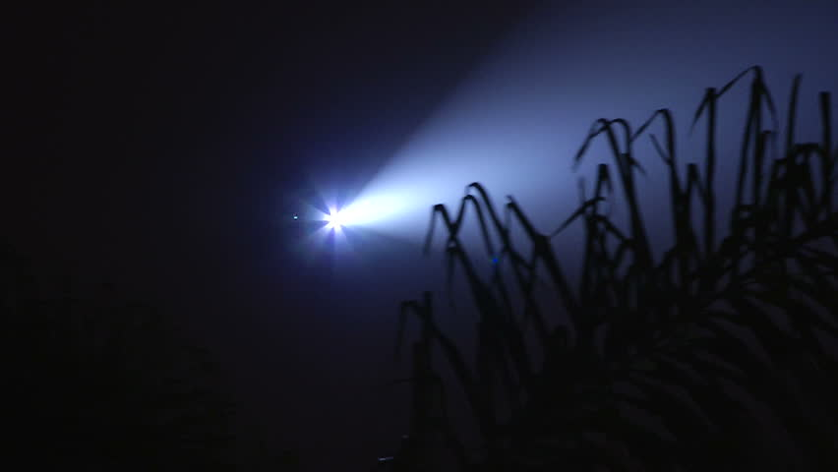](https://www.google.co.uk/url?sa=i&rct=j&q=&esrc=s&source=images&cd=&cad=rja&uact=8&ved=0ahUKEwiL992YzdjTAhWFOBoKHabZB-AQjRwIBw&url=https://www.shutterstock.com/video/clip-3995965-stock-footage-police-helicopter-searchlight-searches-for-suspect.html&psig=AFQjCNFPl53Pqd81AT_MEGh3BxEaCYcLTg&ust=1494068520084940)

https://ak2.picdn.net/shutterstock/videos/3995965/thumb/3.jpg

**Helicopter Beam**

As mentioned previously, there will be a white spotlight which is coming from a helicopter flying above the crime scene. As previously mentioned, this spotlight will shine brighter than the street light lighting as this light will help support the detectives search for the clues in the darkly lit alley. The spotlight will move around the auditorium allowing the audience to become involved as if they are sitting in the crime scene themselves.

**Moving Light**

As stated in the Helicopter Beam section, the white spotlight will move around the auditorium to make the audience feel as if they are sat in the crime scene. I would like to play with the idea of the beam stopping on random members of the audience to make them feel as if they have been selected as a suspect, but then after a couple of seconds the beam will continue moving. I would also like to play with the idea of having more than 1 spot.