[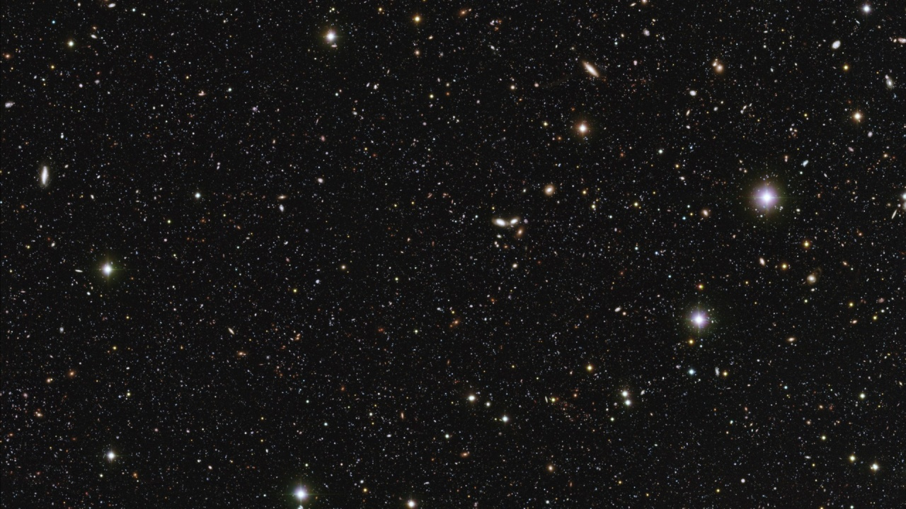](http://www.google.co.uk/url?sa=i&rct=j&q=&esrc=s&source=images&cd=&cad=rja&uact=8&ved=0ahUKEwjYx-WLjdzTAhVCPhQKHUhdAHcQjRwIBw&url=http://wallpaperstock.net/stars-in-outer-space_wallpapers_34707_1280x720_1.html&psig=AFQjCNFpA0QtcltW-KjRnaZcLLeyZrkzIw&ust=1494188747712124)Design 8: Sci-Fi Design

http://wallpaperstock.net/stars-in-outer-space_wallpapers_34707_1280x720.jpg

**Blackout**

The lighting in this section will be incredibly basic. The actual stage will not be lit and the audience will be sat in a blackout. The only thing to light the stage will be the disco ball hanging about the audience. I would like to experiment with light washes of straw to give the effect Alice is passing nearby planets, burning stars or the sun. The information regarding the disco ball and the recreation of the stars will be discussed further below.

**Stars**

Alongside the detective section in the writing scene, Alice takes us on an adventure through space. The most common identification of space is the stars. Stars fill space so my plan is to recreate a number of stars. The image above will be my main inspiration, and to recreate the stars, I will be using the disco ball seen above the audience in the auditorium. With the ball being above the audience allows them also to be a part of space.

[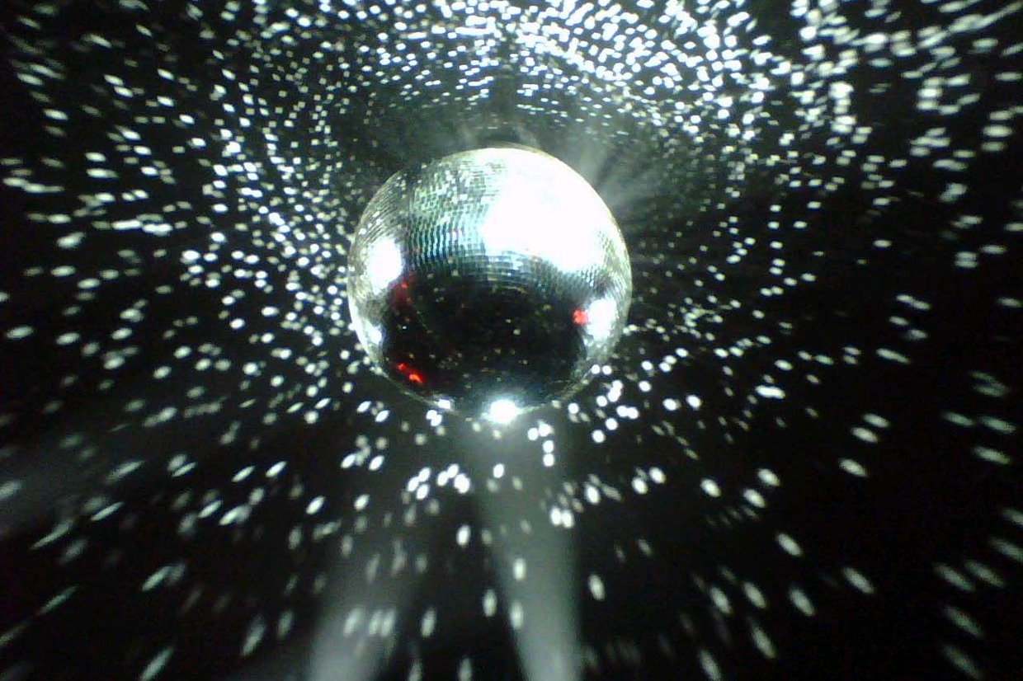](https://www.google.co.uk/url?sa=i&rct=j&q=&esrc=s&source=images&cd=&cad=rja&uact=8&ved=0ahUKEwiM-vmnjtzTAhXKvBQKHV-FAX0QjRwIBw&url=https://www.pinterest.com/pin/44191640071430221/&psig=AFQjCNHme8zL9xFMUITblD27z_gflVvLMA&ust=1494188971461814)

https://s-media-cache-ak0.pinimg.com/originals/2d/f7/98/2df7985a3f1535ecfa78964ecd003bed.jpg

**Disco Ball**

As mentioned previously, to tell the audience the adventure has taken us to space, the disco ball will project stars around the auditorium. As the disco ball is hanging above the audience, the stars will also reflect on the audience members themselves giving them the idea that they are in-fact involved in the story themselves and are also exploring space with Alice herself. The ball will spin slowly as the section is performed extremely slowly.

**Disco Ball Spinning**

With regards to the disco ball spinning, I would like to have in spin as a slow pace. The reason behind this is the characters show they are floating around space slowly and peacefully, passing the stars and planets at a slow pace, and by having the disco ball spin slowly will allow the stars created by the actual ball itself to project and spin around the auditorium slowly. This lighting design is aimed to be peaceful and relaxing allowing a break from the other overdramatic designs.