Design 9: Fantasy Design

https://s-media-cache-ak0.pinimg.com/originals/42/b6/e9/42b6e92ea0683cb4ce14642cf56ee919.jpg

**Colour Scheme**

The colour scheme will consist of 3 main colours: light brown, yellow and Grass Green. The grass green colour will be used to resemble the fresh green grass seen in the image above, the light brown to impersonate the tall beautiful trees, and the yellow to recreate the bright burning sun in the sky. This colour scheme aims to create a relaxed atmosphere, as mentioned previously, a heaven. Everything is bright and fresh.

[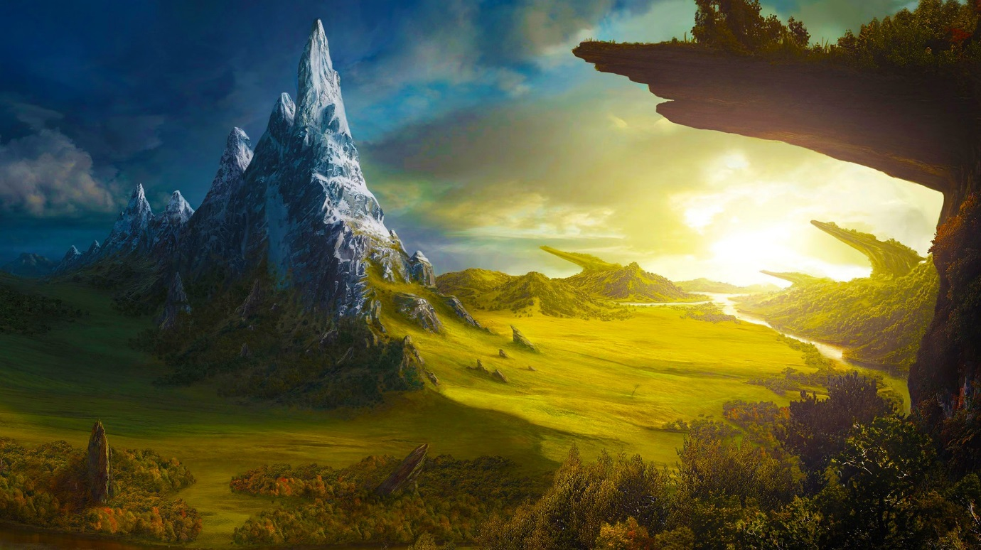](https://www.google.co.uk/url?sa=i&rct=j&q=&esrc=s&source=images&cd=&cad=rja&uact=8&ved=0ahUKEwiZyIbjidfTAhWDL8AKHYYRDQsQjRwIBw&url=https://www.pinterest.com/pin/177610779028867320/&psig=AFQjCNFW5L1Yj2e6pCf3qYvhPo8q0YpLdw&ust=1494016068097679)

**General Wash**

In the writing section, Alice takes us on a journey through a number of different stories as previously mentioned; fantasy being one. This section will have a general wash, as even though the setting is a make-belief land, I would like to create a world which is realistic to Alice’s imagination. The lights will shine bright inspired by the idea of heaven. Heaven is known to be a bright place and this is arguably one of Alice’s heavens.

[](http://www.google.co.uk/url?sa=i&rct=j&q=&esrc=s&source=images&cd=&cad=rja&uact=8&ved=0ahUKEwjai-7yj9fTAhXCthQKHRq5CJwQjRwIBw&url=http://www.wampstore.com/store/Vallejo-Game-Color-Sun-Yellow&psig=AFQjCNG2ihfRBMcsmNFI-vIquA6n6NHhzw&ust=1494017719860336)[](http://www.google.co.uk/url?sa=i&rct=j&q=&esrc=s&source=images&cd=&cad=rja&uact=8&ved=0ahUKEwjK-sKuj9fTAhVDPRQKHfamBqUQjRwIBw&url=http://www.keywordsuggests.com/light-tan-paint-colors/&psig=AFQjCNEg7D3uYmfvh9_Jovz6OZG5O0FaIg&ust=1494017572658586)[](http://www.google.co.uk/url?sa=i&rct=j&q=&esrc=s&source=images&cd=&cad=rja&uact=8&ved=0ahUKEwiLusj1jtfTAhXBQBQKHfxtDpQQjRwIBw&url=http://designinspiration2016.blogspot.com/2016/01/20-shades-of-green-color-name-for.html&psig=AFQjCNF3PXe3DeIeDBmoGHr_oNClQIaJug&ust=1494017458296974)[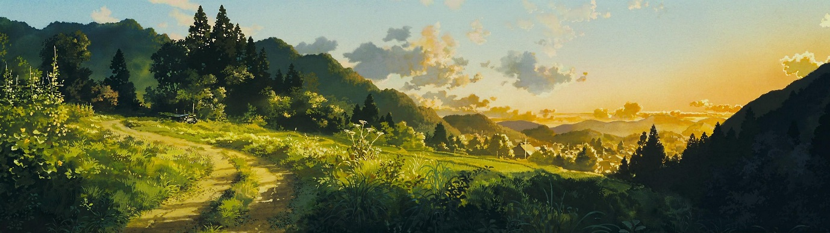](http://www.google.co.uk/url?sa=i&rct=j&q=&esrc=s&source=images&cd=&cad=rja&uact=8&ved=0ahUKEwjnvayjkNfTAhUSnRQKHeuFCOIQjRwIBw&url=http://www.wallpaperup.com/559857/NAUSICAA-VALLEY-WIND_anime_fantasy_adventure_nausicaa_valley_wind.html&psig=AFQjCNGP81a7b9ZhJgXGcVIHmqohLXV9qw&ust=1494017819293416)

**Fantasy Palette**

The colour palette used in the Fantasy section will be bright earthy colours. The aim is to create a bright atmosphere which is open to adventures for Alice to explore. Alice is creating these stories in her imagination, so I would like to re-create a dream like world which could be argued to be a version of Alice’s heaven. As mentioned previously, as seen above, the palette will consist of: grass green to resemble fresh cut grass, light brown to create tall healthy trees in the middle of a meadow and sun yellow to create a bright, sunny and friendly environment. I aim the aura to be warm and Zen however, eager to create adventures. The lights will only shine as a general wash to avoid taking concentration away from the story being told.

http://www.wallpaperup.com/uploads/wallpapers/2014/12/20/559857/2a317b8d83c9073ed6d0c791c7263055.jpg

[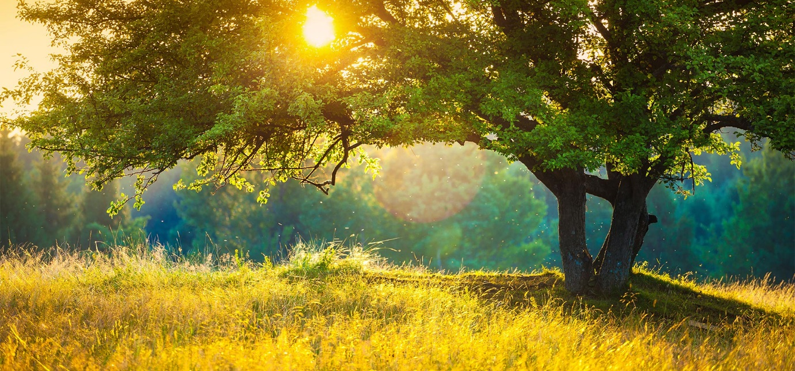](https://www.google.co.uk/url?sa=i&rct=j&q=&esrc=s&source=images&cd=&cad=rja&uact=8&ved=0ahUKEwi8vIqGlNfTAhUFuBQKHdhkAqAQjRwIBw&url=https://www.meditainment.com/country-meadow&psig=AFQjCNEU77SDcE8DbluPnFRDI5VUBly0iw&ust=1494018839016865)

https://www.meditainment.com/images/dmImage/SourceImage/country-meadow.jpg

[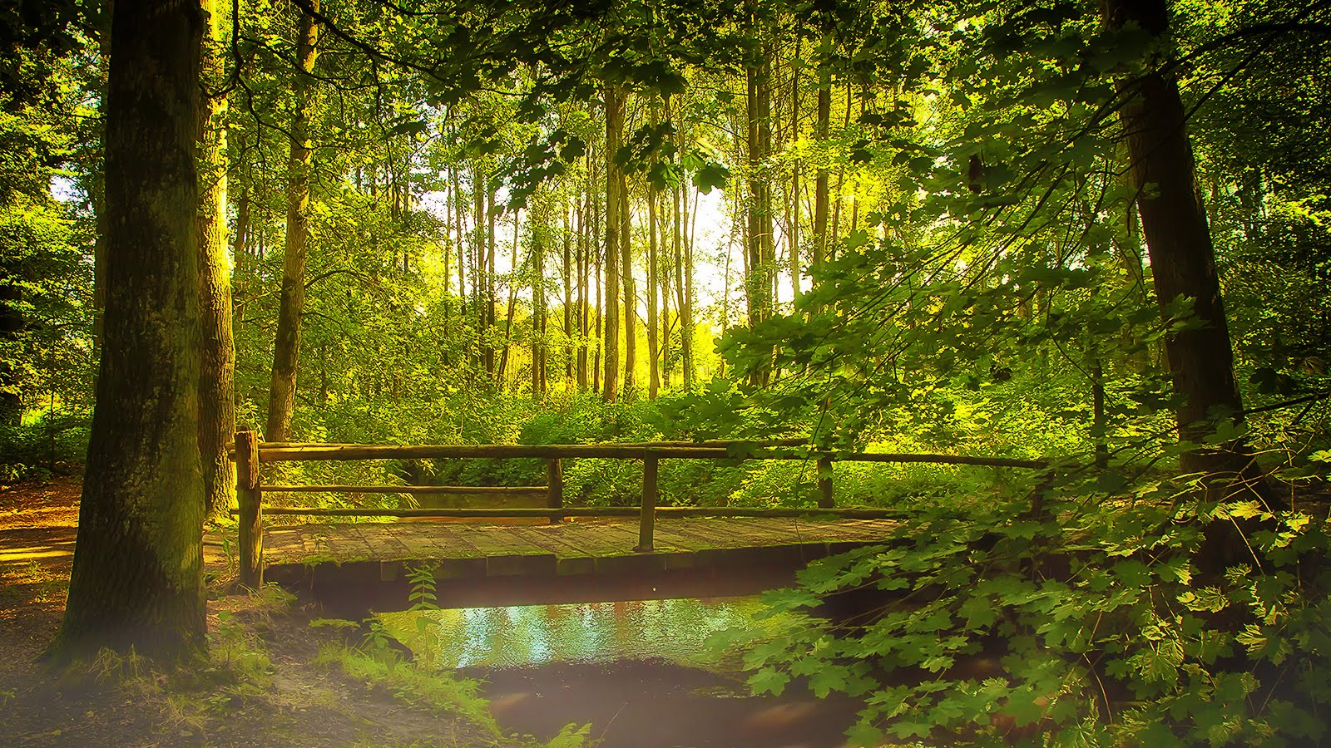](https://www.google.co.uk/url?sa=i&rct=j&q=&esrc=s&source=images&cd=&cad=rja&uact=8&ved=0ahUKEwio8rXMlNfTAhWEORQKHTWXA6sQjRwIBw&url=https://www.youtube.com/watch?v%3D_JsaljhtKHA&psig=AFQjCNEU77SDcE8DbluPnFRDI5VUBly0iw&ust=1494018839016865)

https://i.ytimg.com/vi/_JsaljhtKHA/maxresdefault.jpg

[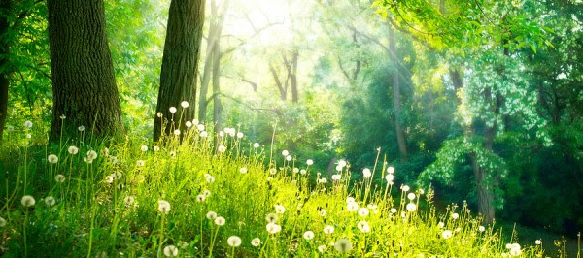](http://www.google.co.uk/url?sa=i&rct=j&q=&esrc=s&source=images&cd=&cad=rja&uact=8&ved=0ahUKEwjN24irldfTAhUF1hQKHcaWAKkQjRwIBw&url=http://omshantiblog.com/inner-action/meditation-and-health/&psig=AFQjCNFeZS9CD1CbflJPAaHDKXnrJ3hwDw&ust=1494019168345175)

http://omshantiblog.com/wp-content/uploads/2014/08/Meadow.png

**Stage Lighting**

To light the stage in the fantasy setting, a yellow light will shine from the top left corner to resemble the sun. The back and sides of the stage will shine light brown and the floor grass green. The light brown sides will blend in with the grass green floor naturally, but this will support the idea of having the light brown trees grow naturally from the green grass. The sun yellow will shine brighter than the light brown and grass green, however, it will not overpower the entire scenery. I would like to experiment will blending sun yellow and a hint of white in the sun to create a more naturalistic setting and possibly resemble a crack within the dream. These world is in fact a make-belief world, however, to Alice’s imagination it is real.