[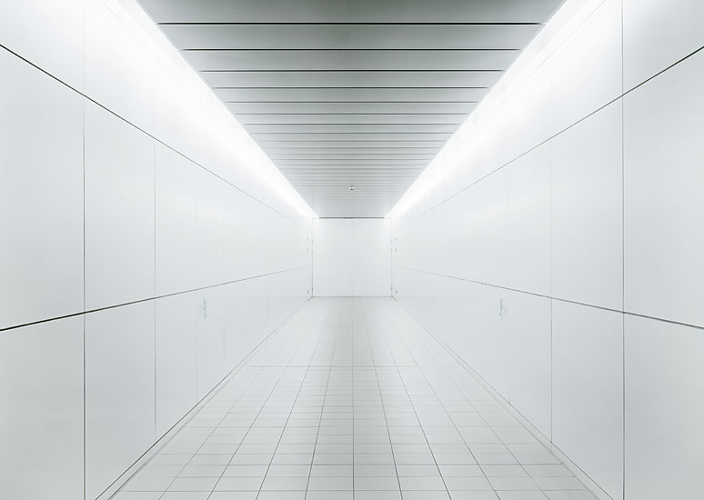](https://www.google.co.uk/url?sa=i&rct=j&q=&esrc=s&source=images&cd=&cad=rja&uact=8&ved=0ahUKEwiPqvqOo7PTAhUEXRQKHRAuAzUQjRwIBw&url=https://uk.pinterest.com/pin/526006431463523109/&psig=AFQjCNEB0K7VNc19PxxW3Kbx9dytcWR0qg&ust=1492785934261982)Design 5: Food Scene

https://s-media-cache-ak0.pinimg.com/originals/b6/81/9d/b6819d2c192acac2d992fd0e6035a7c8.jpg

**General Wash**

Like the childhood scene, the eating scene will consist of a general wash. Once the narrators have entered and Ella (Roxy) is seated and the ‘Gameshow’ design has finished, the lighting will change to a general wash making the atmosphere as realistic as possible. The stage will only be lit with a white light.

**Clinical**

As mentioned in the General Wash, the stage will only be lit with a white light. This is to create a clinical environment to create an uncomfortable atmosphere for both the performers and the audience. As seen in the image above, there is nothing visually pleasing, and displays a creepy aura.

[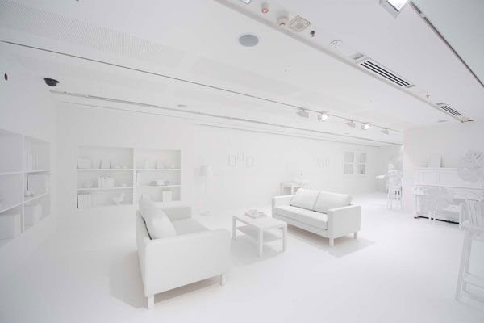](https://www.google.co.uk/url?sa=i&rct=j&q=&esrc=s&source=images&cd=&cad=rja&uact=8&ved=0ahUKEwjpuvqFprPTAhUGtxQKHabdA40QjRwIBw&url=https://avoision.com/2012/01/02/the-obliteration-room-thousands-of-children-with-thousands-of-stickers.php&psig=AFQjCNH8baDEfGQisnWABMETK_u_qHd79g&ust=1492786708358313)

http://avoision.com/wp/wp-content/uploads/2012/01/theObliterationRoom_1.jpg

**Spotlight**

Throughout the scene, the narrators ask who was on Props, and 1 spotlight lights up Pip and Pip only. The colour of the spot is yet to be confirmed as the colour needs to look good with the white lighting. The stage white could be dim, where the spotlight shines brighter, or the spotlight could just be a completely different colour.

**Basic Colour**

There will not be a colour scheme within this design as the stage is lit with only 1 colour to create a clinical atmosphere. The picture above shows a room I would like to recreate in regards to lighting, however, overall the only colour this scene will have is from the costumes from the characters, the cake tins and the actual cakes.