TECHNICAL RIDER: Exit This Way

Company: Fragment Theatre Company
Show: Exit This Way
Date of the show: Friday 19th May 2017

MINIMUM STAGE AREA:

Width: Full width of stage with curtains
Depth: Full depth of stage

STAGE:

- End on (Usual LPAC theatre layout)

SET:

Theatre to provide:
- Chairs (from props store) x 7
- Table (from props store)
- Wooden Stools (from props store) x 2
- 2 x microphone stands
- Two rostra platforms with legs (8 legs – 4 short supplied by LPAC – Fragment to Supply 4 longer ones)
- TVs (some working some not) x 6 + XLR and VGA cables
- 3 x black metal ‘cages’ (6ft x 8ft) with steps either side and walkway across the top with handrails at the back

Company to provide:
- TVs (some working some not/broken) x 3
- ‘Rubbish’ – (magazines, books, general clutter)
- Exercise bike
- Mannequin

SOUND:

We will require
- 2 x microphone stands
- 3 x wireless microphones (operated from technical box)
- Theatre speakers

LIGHTING:

Theatre to provide:
- Access to lighting rig in LPAC theatre
Also see lighting design/mood boards attached in the email for visuals of the sort of thing we are aiming for.

VIDEO:
- TV screens will be used to play pre-recorded AV

PROPERTIES:
These will all be provided by Fragment Theatre Company (unless stated otherwise) and brought with us for both our Technical Rehearsal and Performance day:

- Victoria Sponge Cake
- Carrot Cake
- Jaffa Cake
- Red Velvet Cake
- Chocolate Cake
- 5 x Cloches and plates
- Cake Cutter
- Water Bottles (Lucozade Sport)
- Washing Basket
- Remotes
- Magazines
- Mugs
- Photo frames
- Dressing Gown
- Saucepans/kitchen stuff
- Sheets
- Washing Line to peg sheet to – tied between to bits of scaffolding
- Pegs
- Peg bag
- Mirror
- Crown
- Tiara
- Pumpkin Chariot Cut Out
- Flower
- Bag
- Glasses
- Invite
- Speech Bubble
- Spinster Stuff – blanket/shawl
- Dress + coat hanger
- Feather Pen
- Scroll
- Troll stuff – horns
- Something for Lucy to use to block light
- Loo roll crime tape
- Disposable camera
- Tennis racket/ping-pong racket/loo roll tube as magnifying glass
- Notebook
- Umbrella sword/shield
- Cardboard box armour
- Croissant and Baguette hobby horses
- Cardboard monster/beast
- Golden wig
- Colander/bowl etc. helmets
- Lots of Tin Foil
- Model Planet
- Stick and fishing wire
- Inflatable aliens
- Water spray bottle
- Fan
- Leaves
- Brooms x3
- ‘Drag props’ – feather boa etc.

OPERATION:

- We will require an in house technician to run sound, light and AV from technical box via computer
- Our Company’s Stage Manager will be backstage organising set changes and props

TIME IN VENUE:

Technical Rehearsal (Thursday 18th May):
- Get in 9am
- Get out 1pm

Show Day (Friday 19th May):
- Get in 9am
- Show will begin at 7.30pm
- Show running time approximately 60 minutes
- Get out by 10pm

(Day schedule for both days will be sent to lpactech@lincoln.ac.uk no later than Friday 11th May 2017)

ADDITIONAL INFORMATION
One of our actors will be eating a lot of cake and exercising on an exercise bike throughout the performance. The relevant precautions have been discussed with the actor and will be fully laid out in the risk assessment. Our stage manager will brief front of house staff and any first aiders we have available to us in the theatre on show day.

If you need any more information just contact our Stage Manager Lucy Workman on 13464800@students.lincoln.ac.uk
9 TV’s on stage from the start. 6 of which will be fully functioning and show footage at a part in the show.

Two manikins upstage in front of the steps. These are to hold the costumes on that the actors put on and take off throughout the performance.
Fragment Theatre Company
Exit This Way
Set Design
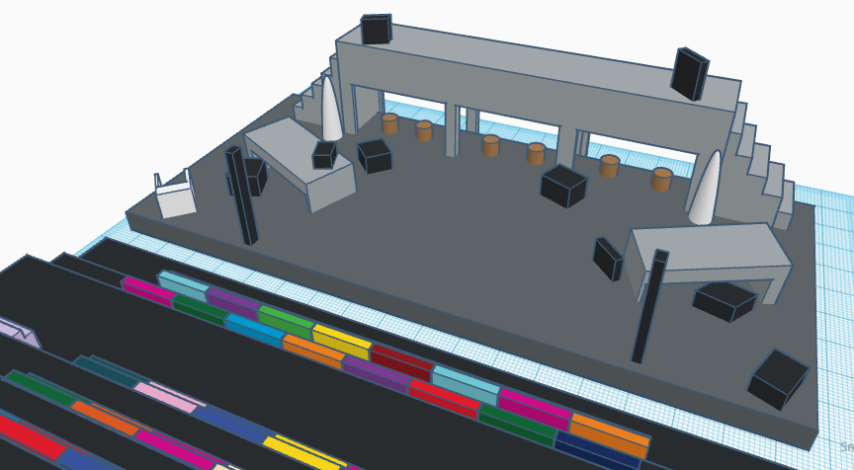
6 small brown stools at the back of the stage under the black metal cage for each cast member to sit on.

Two microphone stands downstage at both sides.
80cm
95cm
6ft
8ft

Exercise bike situated stage right next to table and chair. All present on stage throughout, initially hidden by a sheet.

Other props and litter scattered all over the stage, often moved by the actors throughout.

Two smaller rostrums nearer the front of the stage cluttered with litter.

